Test Case: tc010_SPX_Dev5_Validacion_Agregar_Remover_Articulos_Controlados
Step 1 - Enter username and password and click to button Enter : Credentials Entered
Image file-name: QC_Testing-runTestMultipleTimes-nov. 20 2025, 02 39 41 p. m.

Image file-name: QC_Testing-runTestMultipleTimes-nov. 20 2025, 02 39 42 p. m.

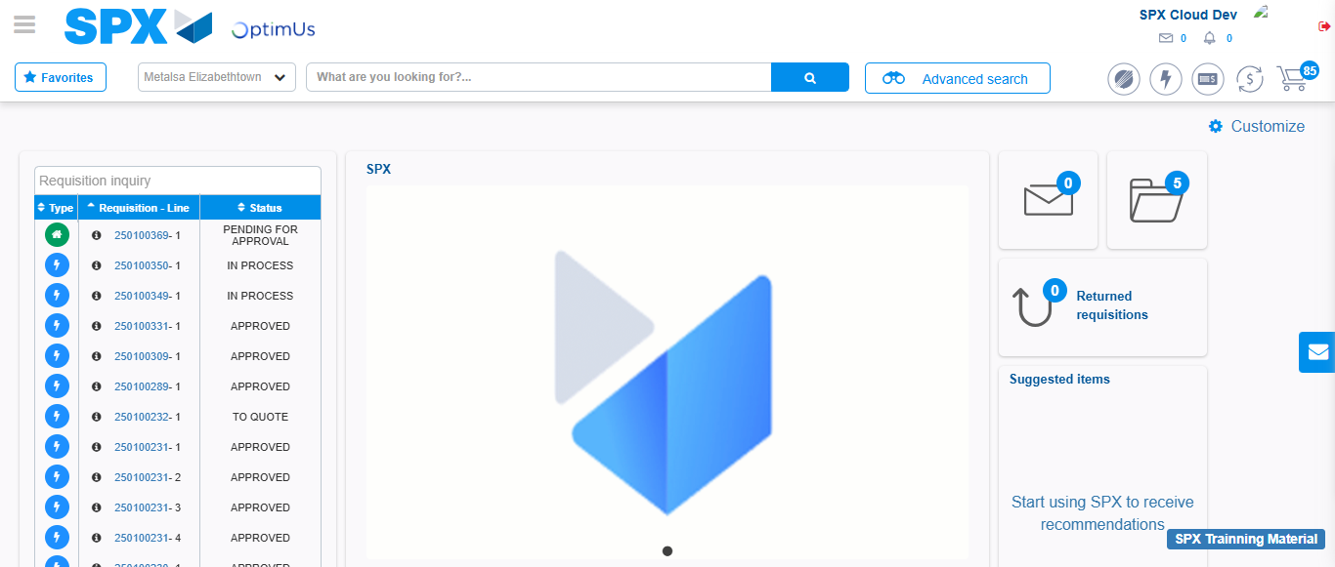Image file-name: QC_Testing-tc001_SPX_Dev5_Validar_Filtro_Campo_MenuName_Administrador_Roles_Menu-nov. 20 2025, 02 40 13 p. m.

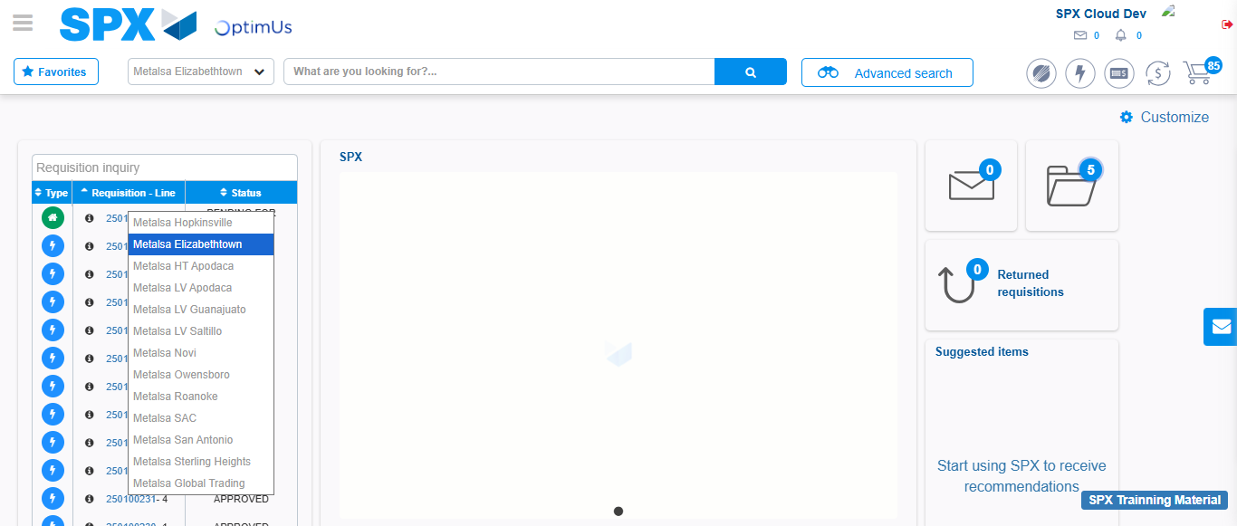Image file-name: QC_Testing-tc002_SPX_Dev5_Validar_Filtro_Campo_URLPath_Administrador_Roles_Menu-nov. 20 2025, 02 40 36 p. m.

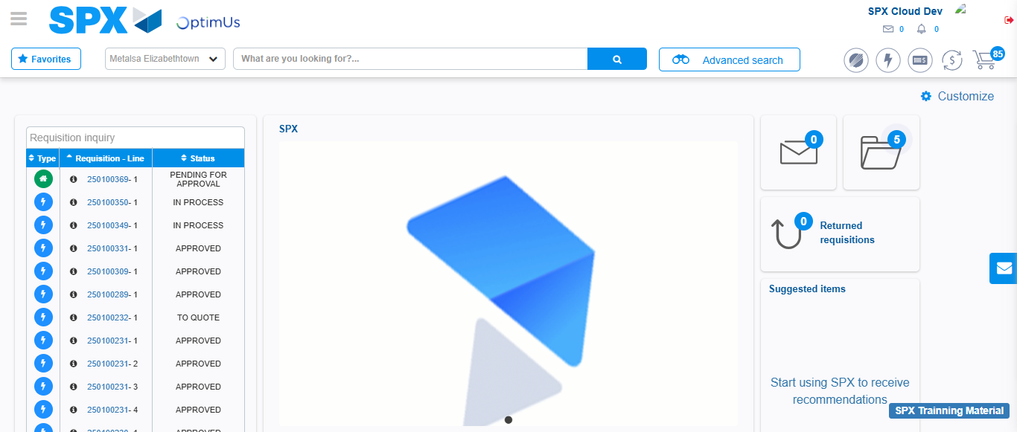Image file-name: QC_Testing-tc003_SPX_Dev5_Validar_Funcionalidad_Botones_Add_Remove_Administrador_Roles_Menu-nov. 20 2025, 02 41 01 p. m.

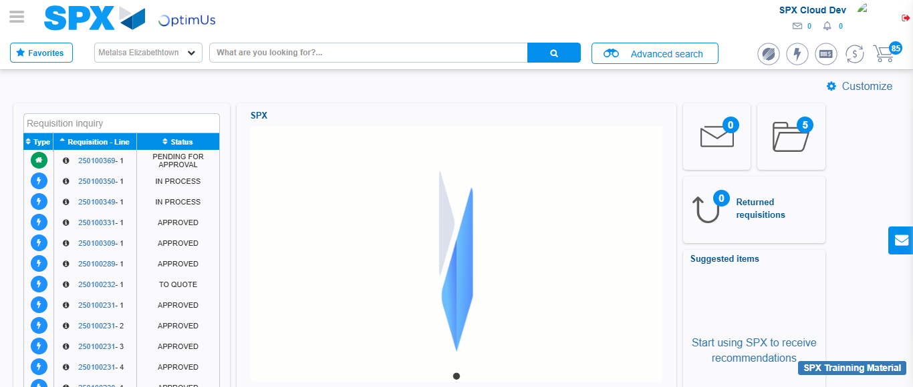Image file-name: QC_Testing-tc004_SPX_Dev5_Validacion_Filtro_Campo_MenuName_Administrador_Menu-nov. 20 2025, 02 41 30 p. m.

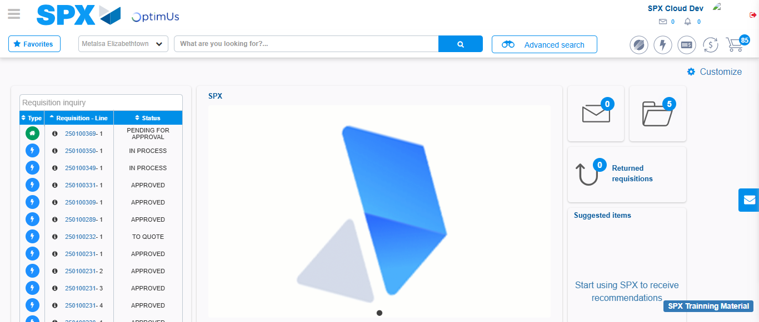Image file-name: QC_Testing-tc005_SPX_Dev5_Validacion_Filtro_Campo_URLPath_Administrador_Menu-nov. 20 2025, 02 41 51 p. m.

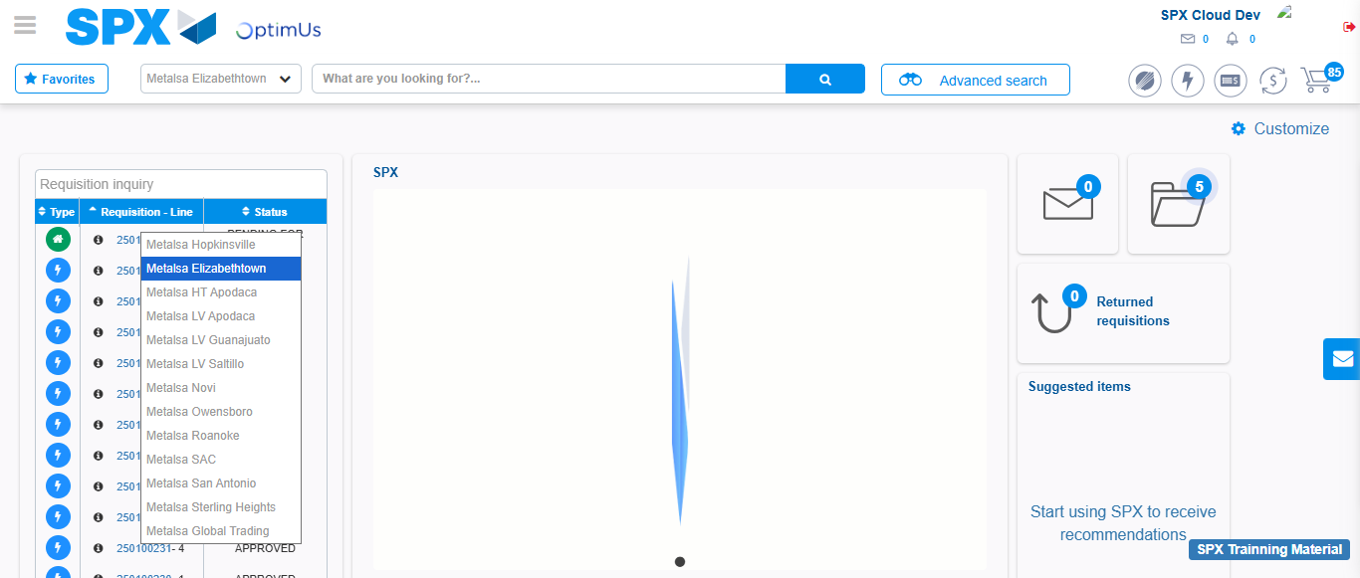Image file-name: QC_Testing-tc006_SPX_Dev5_Validacion_Boton_AddNewMenu_Administrador_Menu-nov. 20 2025, 02 42 19 p. m.

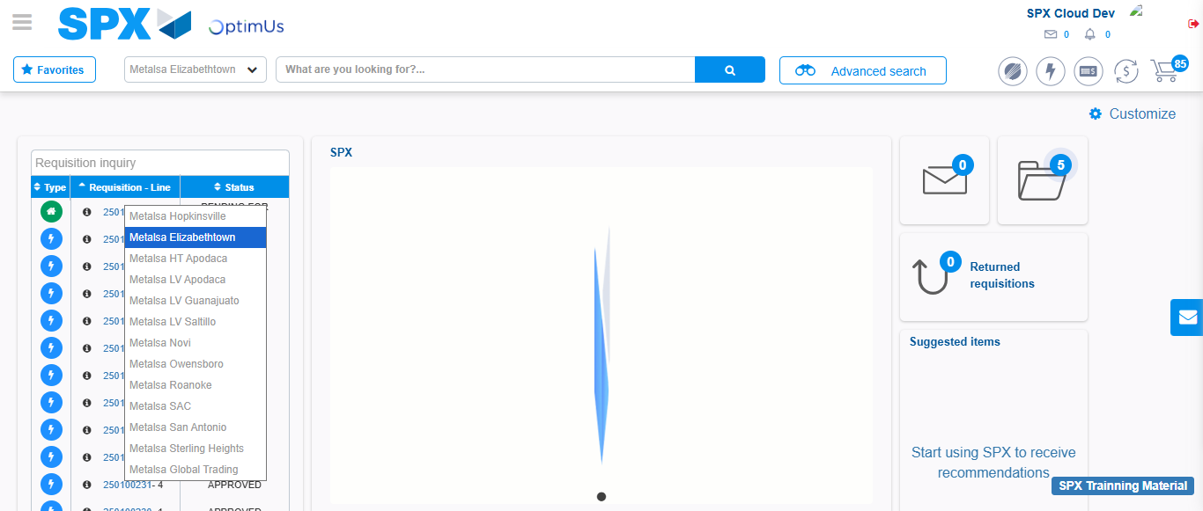Image file-name: QC_Testing-tc007_SPX_Dev5_Validacion_Boton_Edit_Administrador_Menu-nov. 20 2025, 02 42 50 p. m.

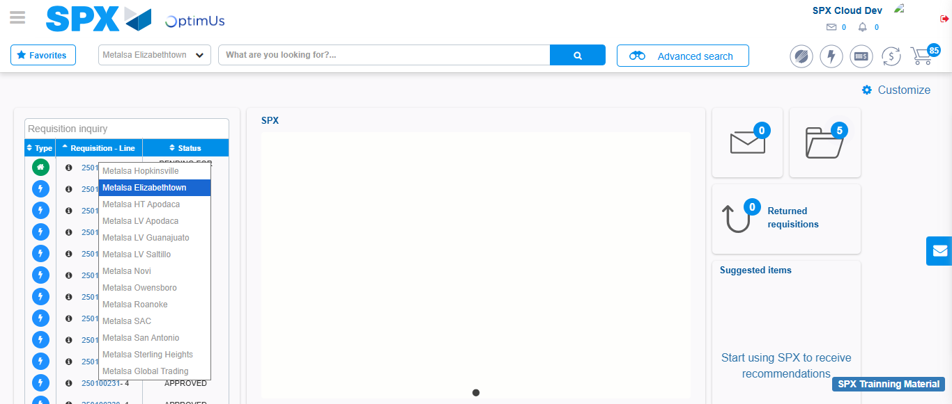Image file-name: QC_Testing-tc008_SPX_Dev5_Validacion_Boton_Remove_Administrador_Menu-nov. 20 2025, 02 43 20 p. m.

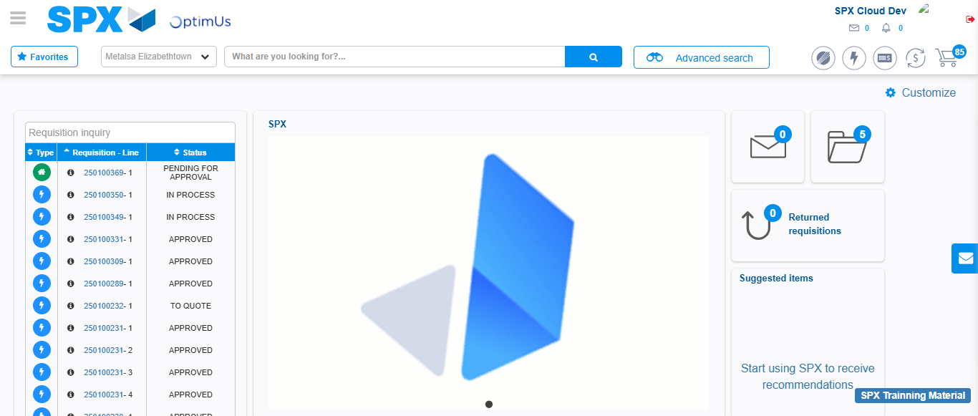Image file-name: QC_Testing-tc009_SPX_Dev5_Validacion_Campos_Busqueda_Articulos_Controlados-nov. 20 2025, 02 43 44 p. m.

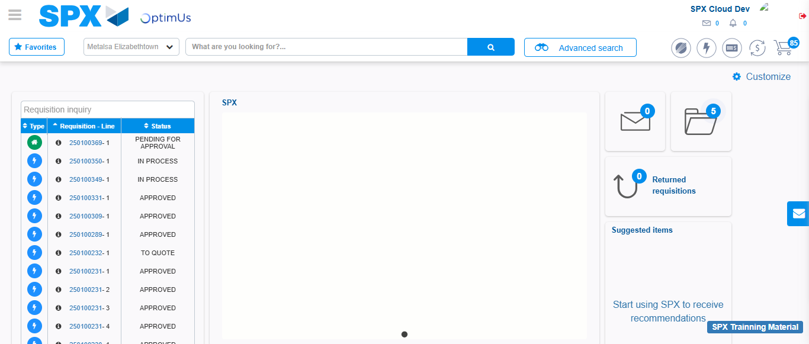Image file-name: QC_Testing-tc010_SPX_Dev5_Validacion_Agregar_Remover_Articulos_Controlados-nov. 20 2025, 02 44 42 p. m.

Step 2 - Select to UEN and Access to Articulos Controlados: UEN Correctly selected and Correct access
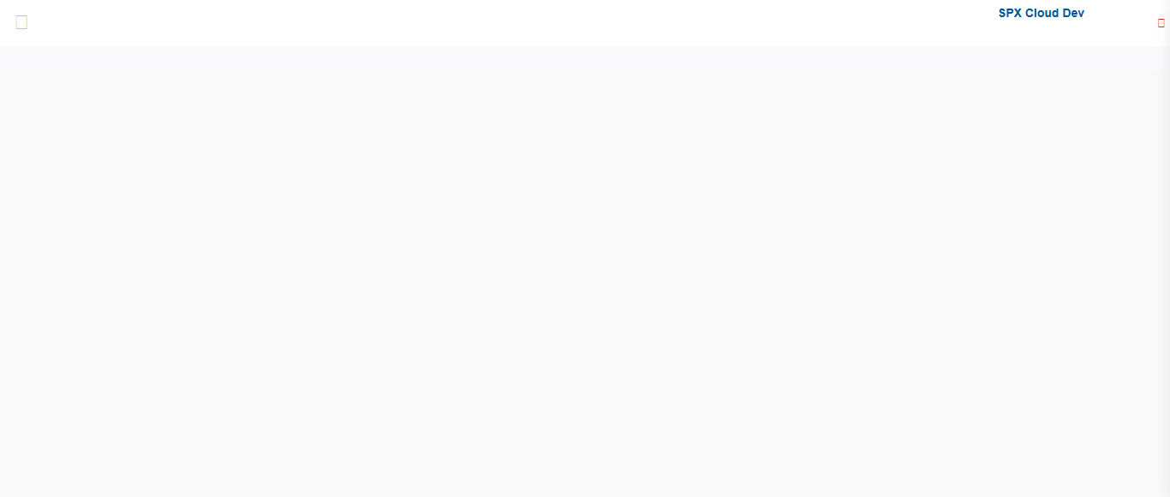Image file-name: QC_Testing-runTestMultipleTimes-nov. 20 2025, 02 39 51 p. m.

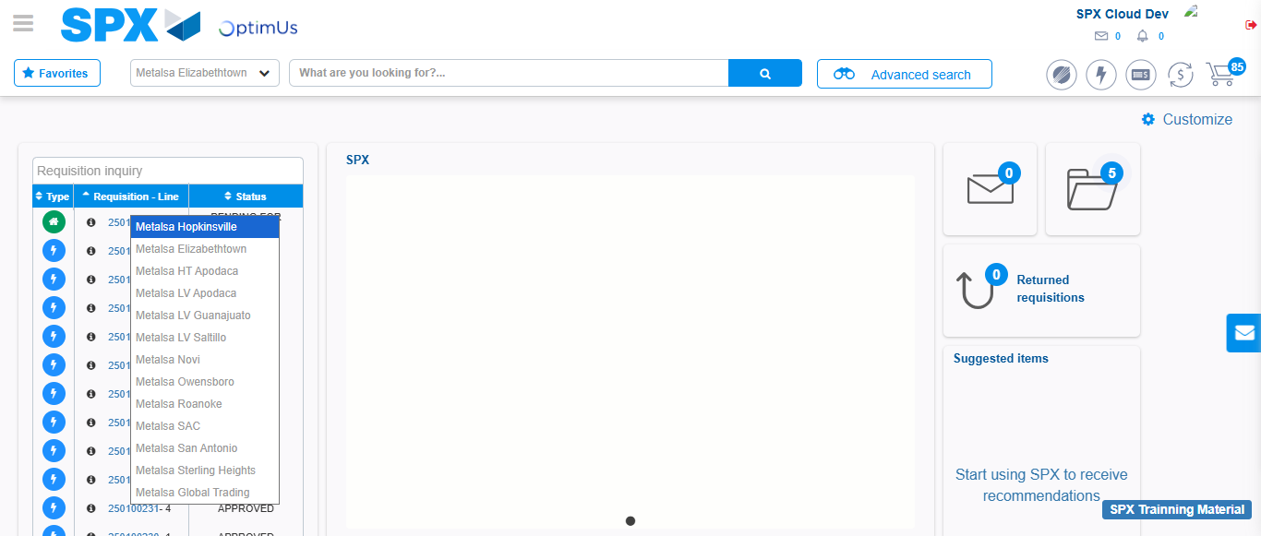Image file-name: QC_Testing-runTestMultipleTimes-nov. 20 2025, 02 39 52 p. m.

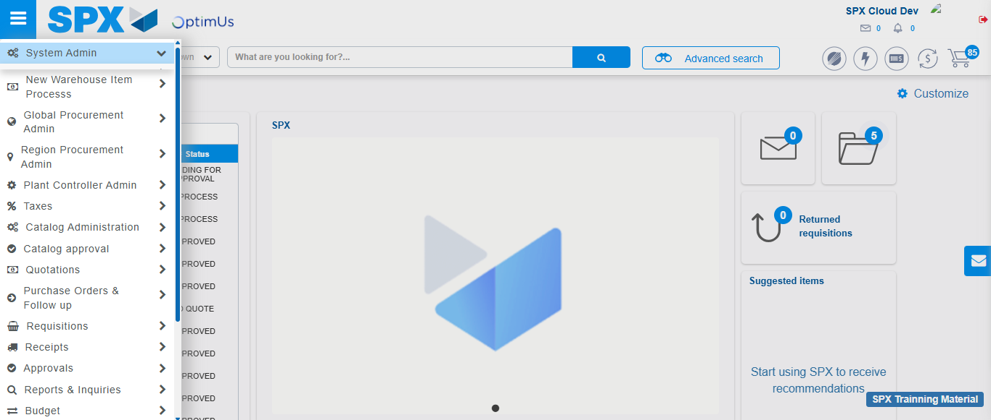Image file-name: QC_Testing-runTestMultipleTimes-nov. 20 2025, 02 39 53 p. m.

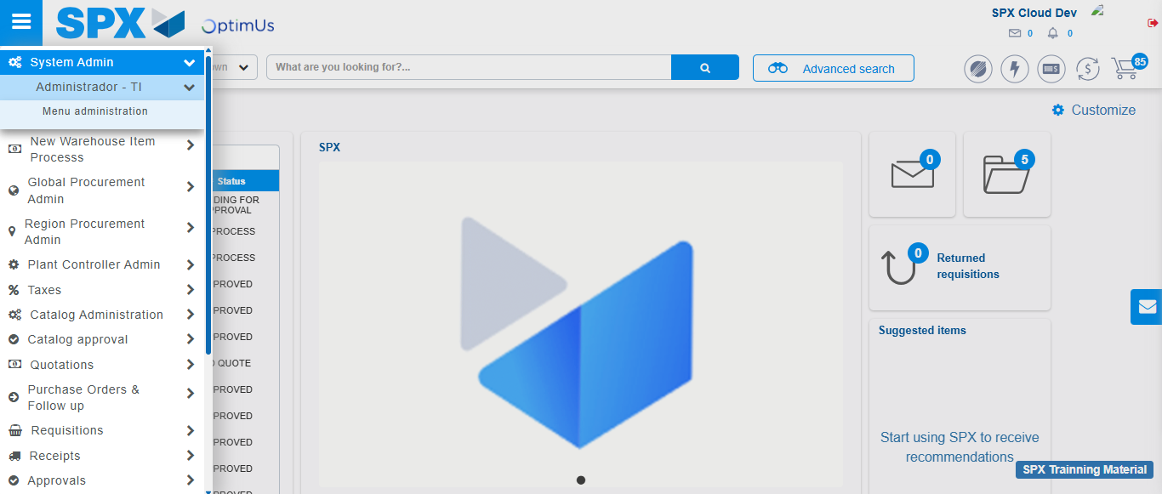Image file-name: QC_Testing-runTestMultipleTimes-nov. 20 2025, 02 39 54 p. m.

Image file-name: QC_Testing-runTestMultipleTimes-nov. 20 2025, 02 39 57 p. m.

Image file-name: QC_Testing-tc001_SPX_Dev5_Validar_Filtro_Campo_MenuName_Administrador_Roles_Menu-nov. 20 2025, 02 40 13 p. m.

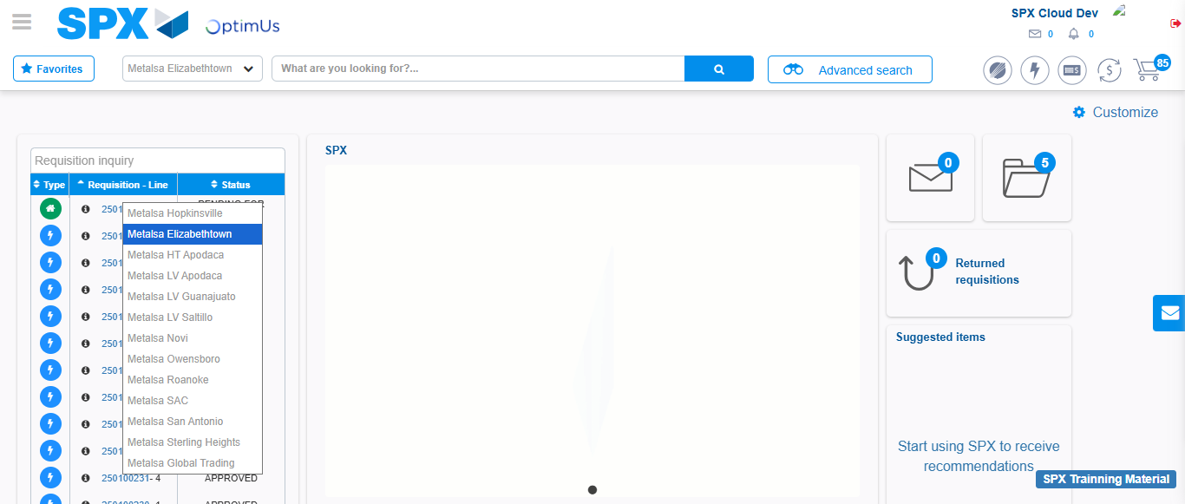Image file-name: QC_Testing-tc001_SPX_Dev5_Validar_Filtro_Campo_MenuName_Administrador_Roles_Menu-nov. 20 2025, 02 40 14 p. m.

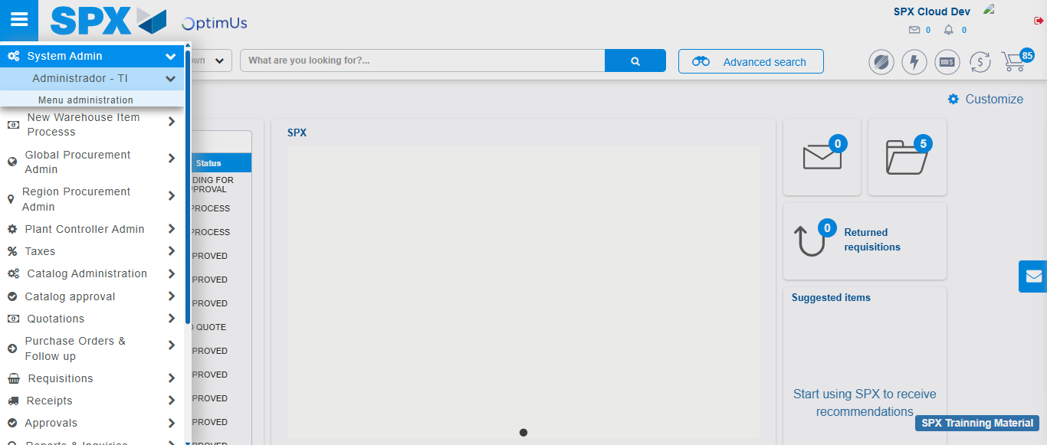Image file-name: QC_Testing-tc001_SPX_Dev5_Validar_Filtro_Campo_MenuName_Administrador_Roles_Menu-nov. 20 2025, 02 40 15 p. m.

Image file-name: QC_Testing-tc001_SPX_Dev5_Validar_Filtro_Campo_MenuName_Administrador_Roles_Menu-nov. 20 2025, 02 40 17 p. m.

Image file-name: QC_Testing-tc002_SPX_Dev5_Validar_Filtro_Campo_URLPath_Administrador_Roles_Menu-nov. 20 2025, 02 40 36 p. m.

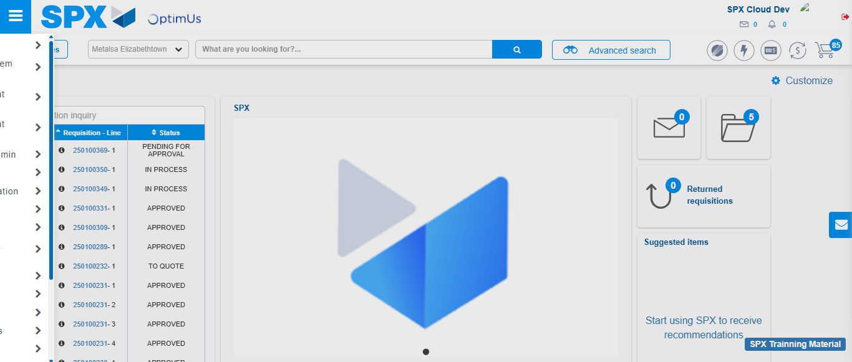Image file-name: QC_Testing-tc002_SPX_Dev5_Validar_Filtro_Campo_URLPath_Administrador_Roles_Menu-nov. 20 2025, 02 40 37 p. m.

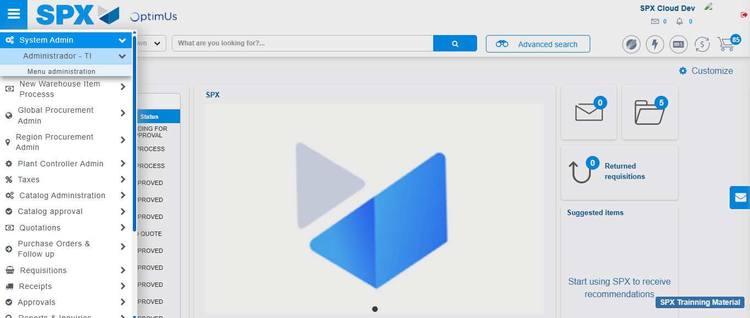Image file-name: QC_Testing-tc002_SPX_Dev5_Validar_Filtro_Campo_URLPath_Administrador_Roles_Menu-nov. 20 2025, 02 40 38 p. m.

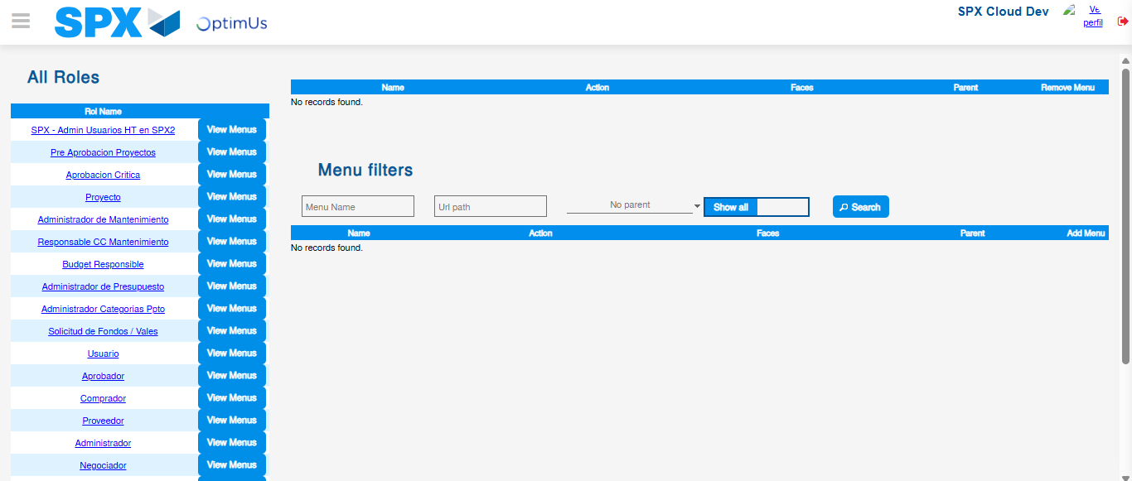Image file-name: QC_Testing-tc002_SPX_Dev5_Validar_Filtro_Campo_URLPath_Administrador_Roles_Menu-nov. 20 2025, 02 40 40 p. m.

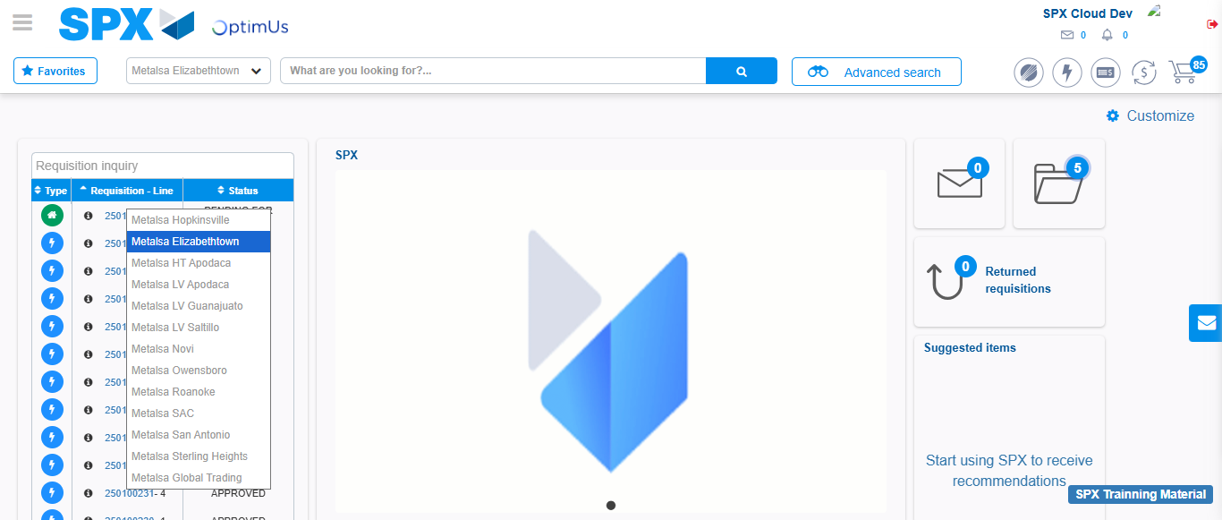Image file-name: QC_Testing-tc003_SPX_Dev5_Validar_Funcionalidad_Botones_Add_Remove_Administrador_Roles_Menu-nov. 20 2025, 02 41 02 p. m.

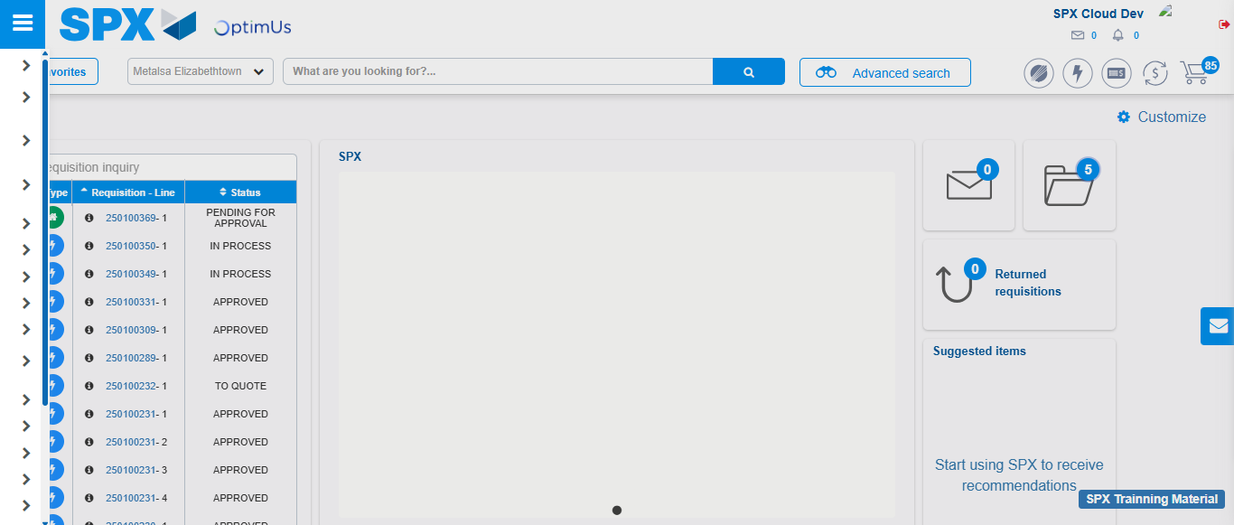Image file-name: QC_Testing-tc003_SPX_Dev5_Validar_Funcionalidad_Botones_Add_Remove_Administrador_Roles_Menu-nov. 20 2025, 02 41 03 p. m.

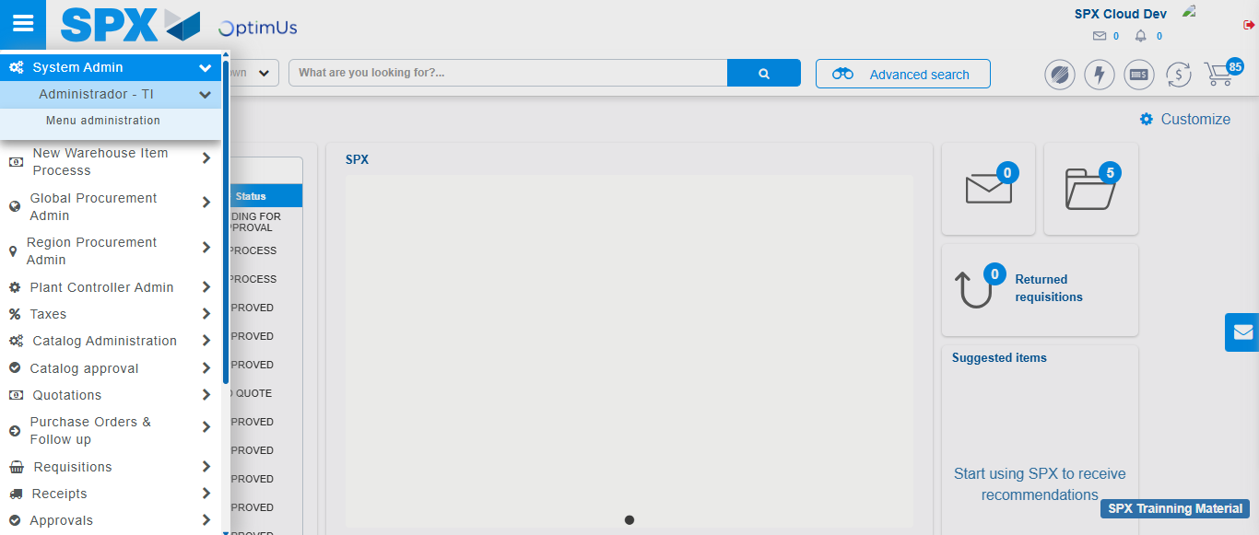Image file-name: QC_Testing-tc003_SPX_Dev5_Validar_Funcionalidad_Botones_Add_Remove_Administrador_Roles_Menu-nov. 20 2025, 02 41 04 p. m.

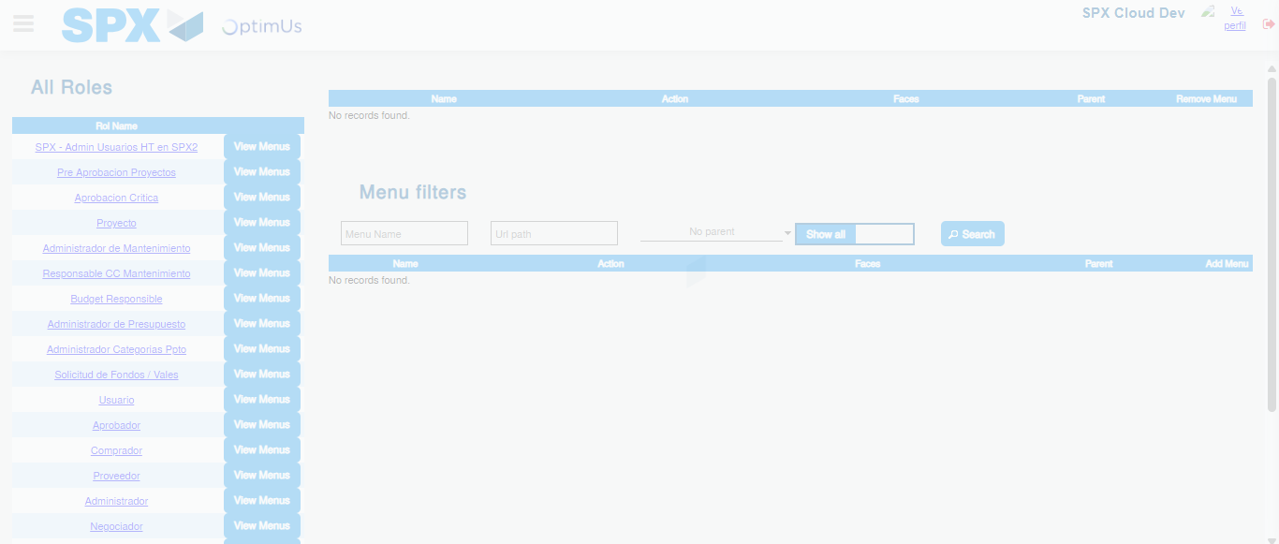Image file-name: QC_Testing-tc003_SPX_Dev5_Validar_Funcionalidad_Botones_Add_Remove_Administrador_Roles_Menu-nov. 20 2025, 02 41 06 p. m.

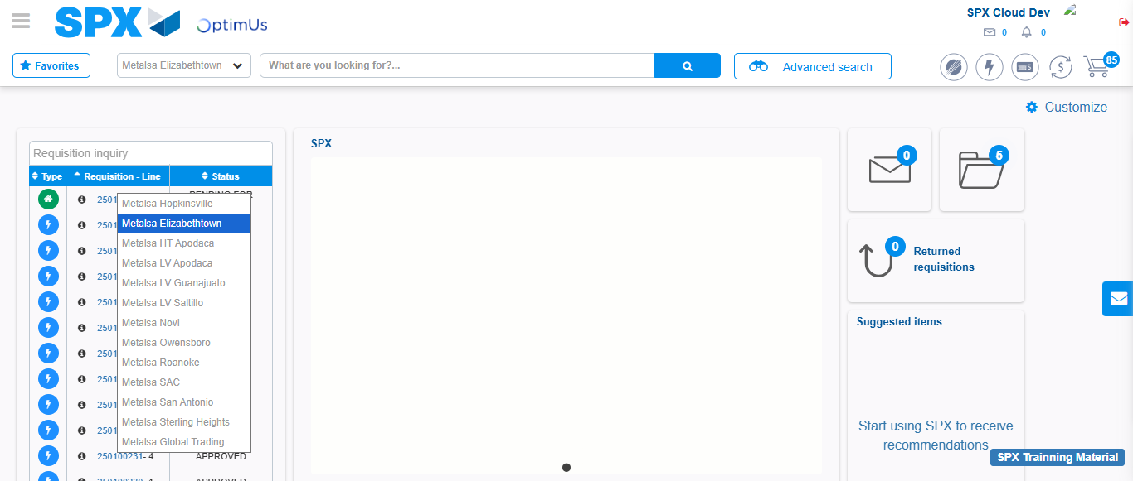Image file-name: QC_Testing-tc004_SPX_Dev5_Validacion_Filtro_Campo_MenuName_Administrador_Menu-nov. 20 2025, 02 41 31 p. m.

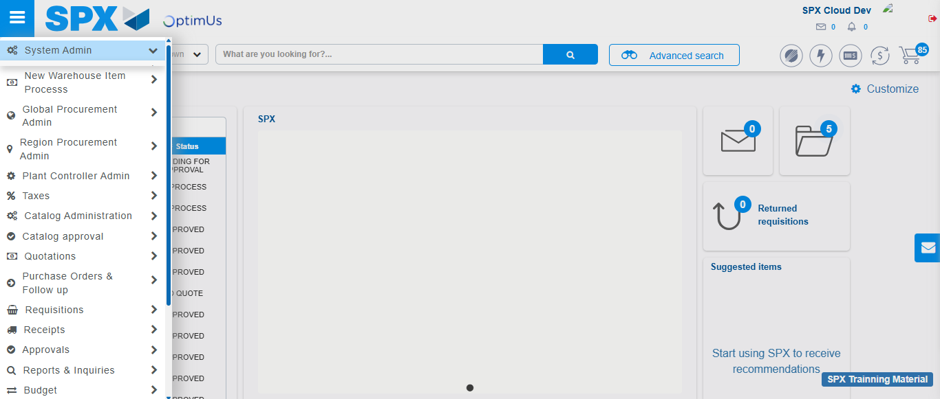Image file-name: QC_Testing-tc004_SPX_Dev5_Validacion_Filtro_Campo_MenuName_Administrador_Menu-nov. 20 2025, 02 41 32 p. m.

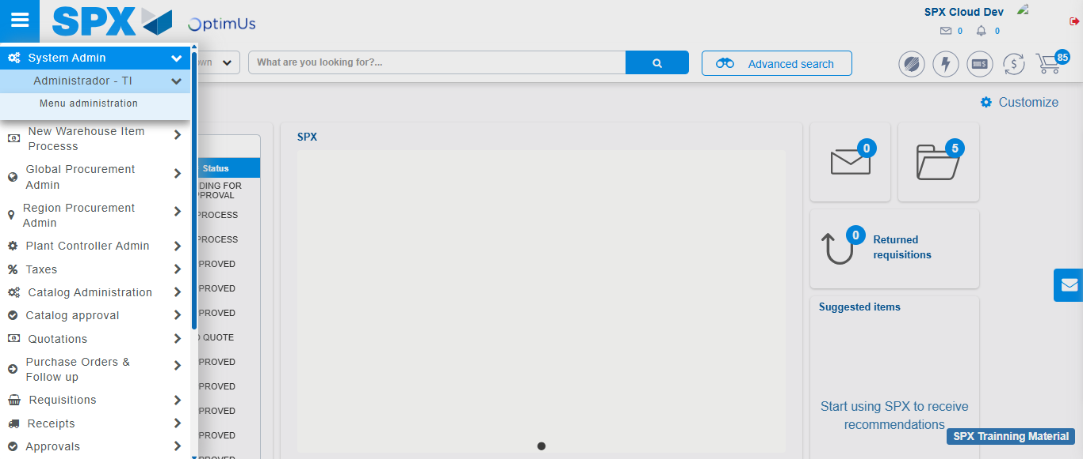Image file-name: QC_Testing-tc004_SPX_Dev5_Validacion_Filtro_Campo_MenuName_Administrador_Menu-nov. 20 2025, 02 41 33 p. m.

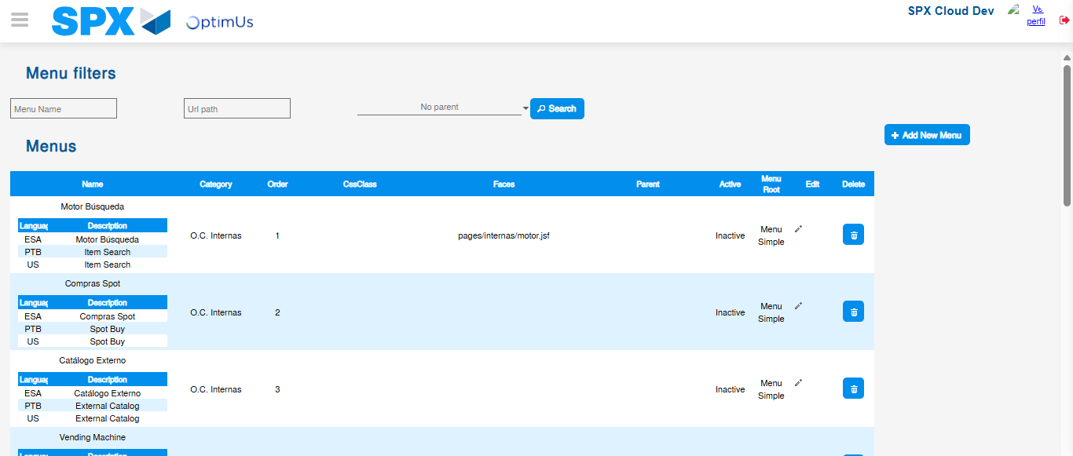Image file-name: QC_Testing-tc004_SPX_Dev5_Validacion_Filtro_Campo_MenuName_Administrador_Menu-nov. 20 2025, 02 41 34 p. m.

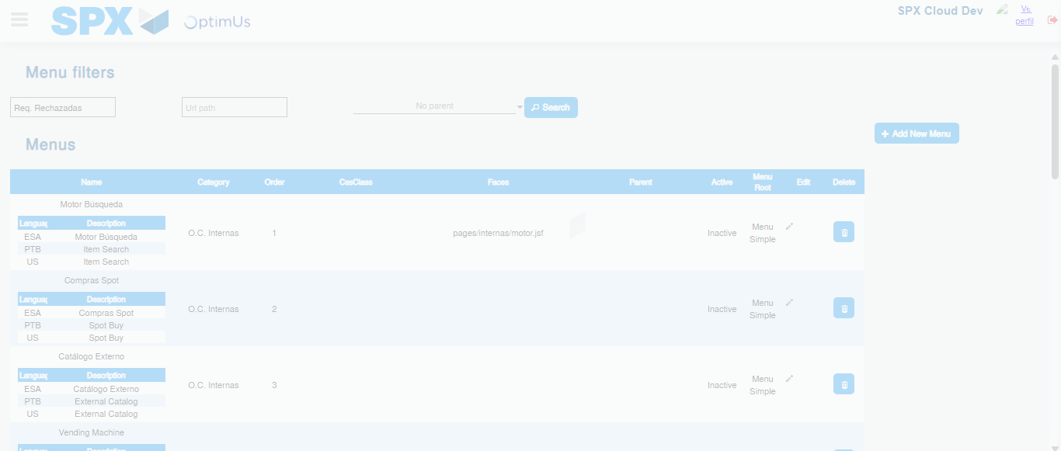Image file-name: QC_Testing-tc004_SPX_Dev5_Validacion_Filtro_Campo_MenuName_Administrador_Menu-nov. 20 2025, 02 41 35 p. m.

Image file-name: QC_Testing-tc005_SPX_Dev5_Validacion_Filtro_Campo_URLPath_Administrador_Menu-nov. 20 2025, 02 41 51 p. m.

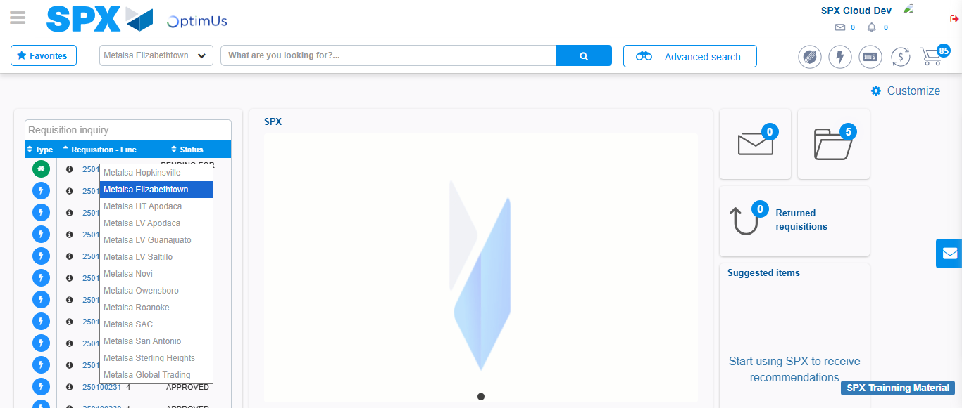Image file-name: QC_Testing-tc005_SPX_Dev5_Validacion_Filtro_Campo_URLPath_Administrador_Menu-nov. 20 2025, 02 41 52 p. m.

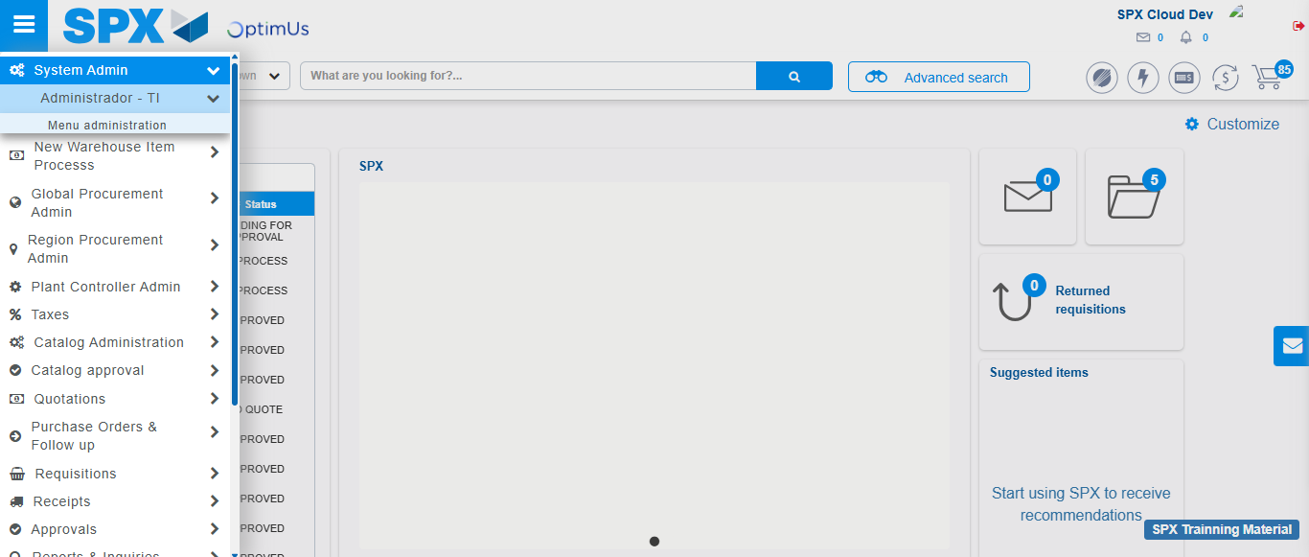Image file-name: QC_Testing-tc005_SPX_Dev5_Validacion_Filtro_Campo_URLPath_Administrador_Menu-nov. 20 2025, 02 41 53 p. m.

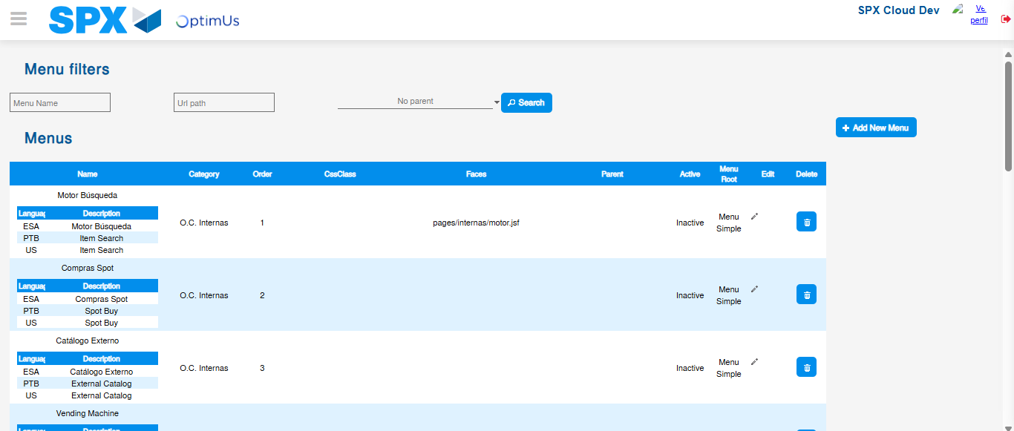Image file-name: QC_Testing-tc005_SPX_Dev5_Validacion_Filtro_Campo_URLPath_Administrador_Menu-nov. 20 2025, 02 42 00 p. m.

Image file-name: QC_Testing-tc006_SPX_Dev5_Validacion_Boton_AddNewMenu_Administrador_Menu-nov. 20 2025, 02 42 19 p. m.

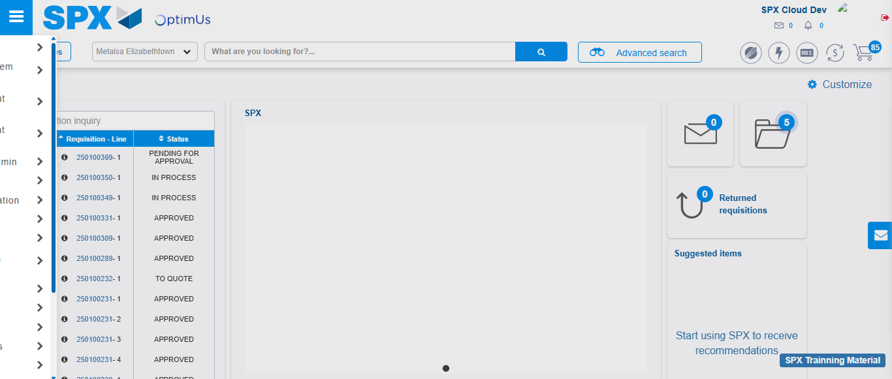Image file-name: QC_Testing-tc006_SPX_Dev5_Validacion_Boton_AddNewMenu_Administrador_Menu-nov. 20 2025, 02 42 20 p. m.

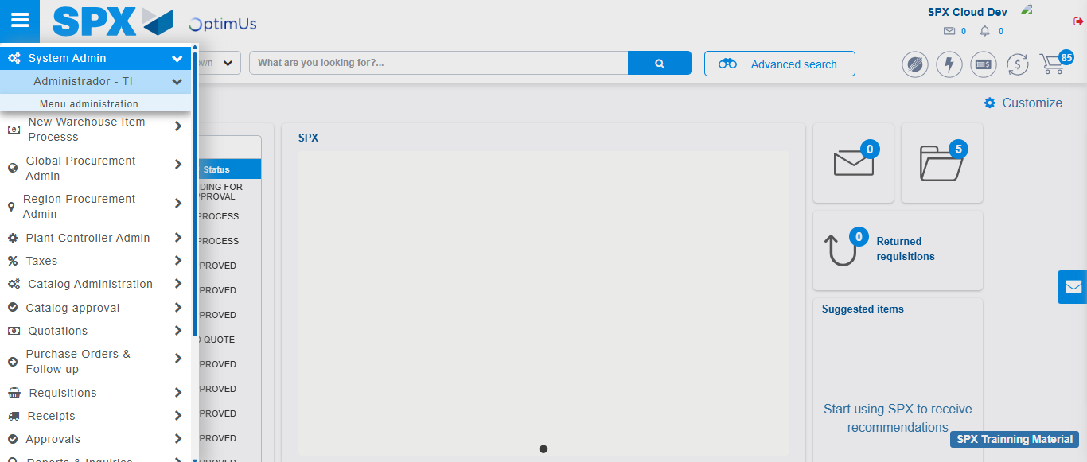Image file-name: QC_Testing-tc006_SPX_Dev5_Validacion_Boton_AddNewMenu_Administrador_Menu-nov. 20 2025, 02 42 21 p. m.

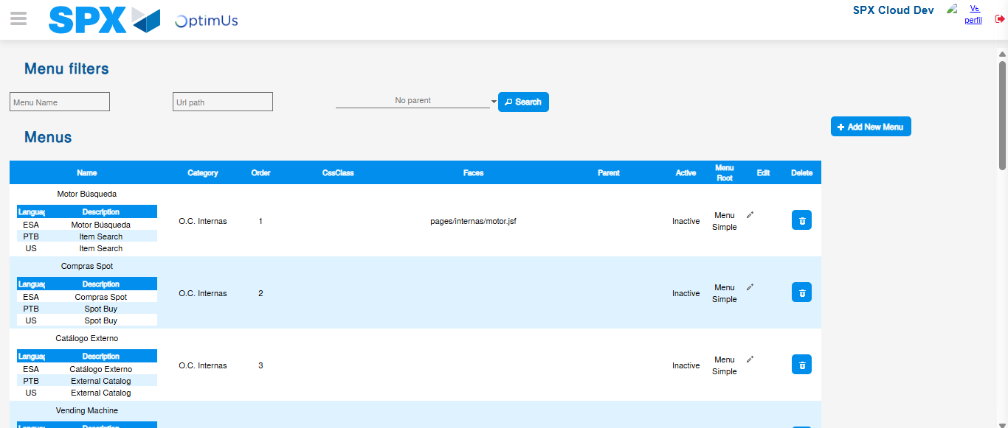Image file-name: QC_Testing-tc006_SPX_Dev5_Validacion_Boton_AddNewMenu_Administrador_Menu-nov. 20 2025, 02 42 24 p. m.

Image file-name: QC_Testing-tc007_SPX_Dev5_Validacion_Boton_Edit_Administrador_Menu-nov. 20 2025, 02 42 50 p. m.

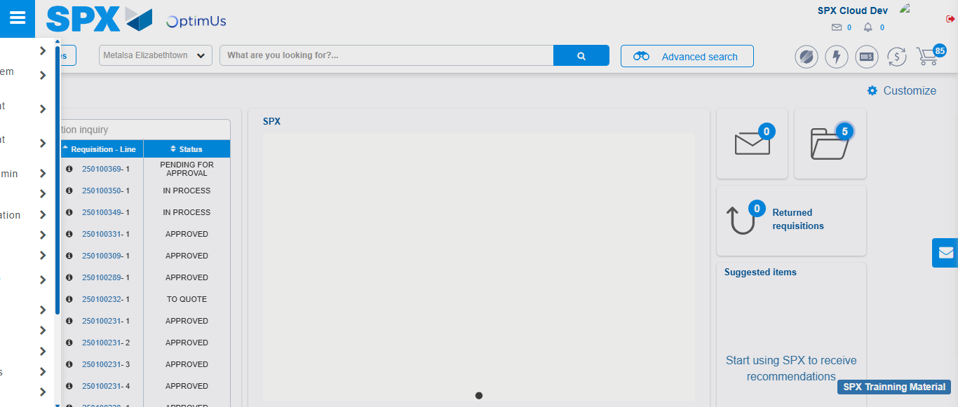Image file-name: QC_Testing-tc007_SPX_Dev5_Validacion_Boton_Edit_Administrador_Menu-nov. 20 2025, 02 42 51 p. m.

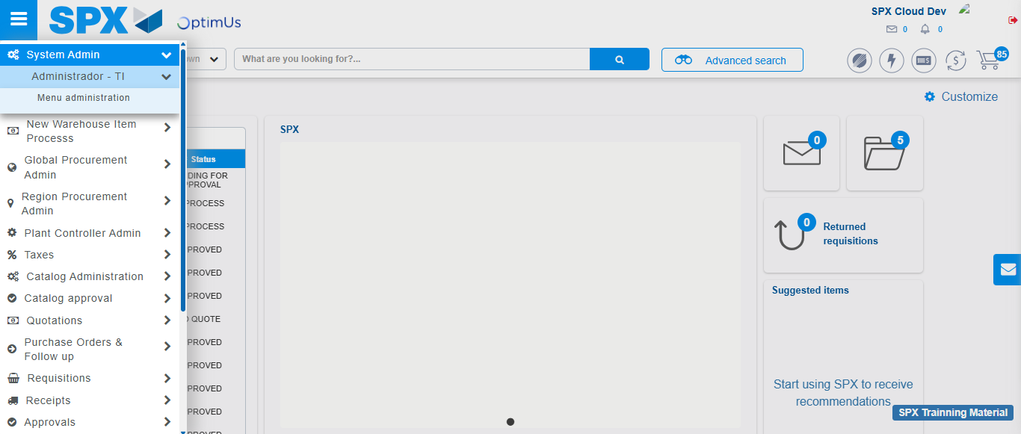Image file-name: QC_Testing-tc007_SPX_Dev5_Validacion_Boton_Edit_Administrador_Menu-nov. 20 2025, 02 42 52 p. m.

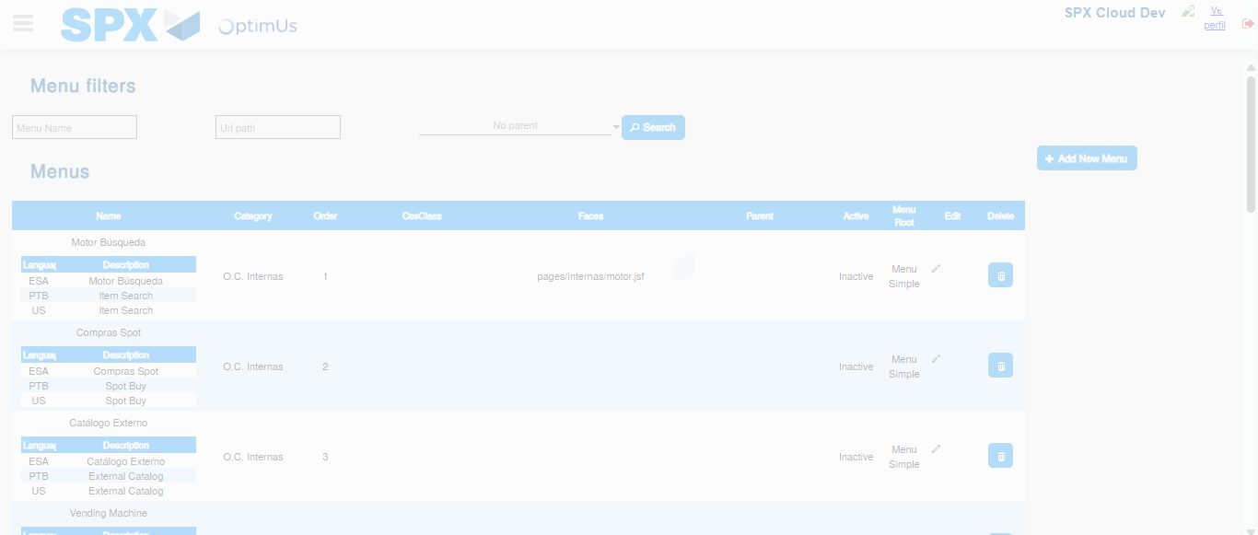Image file-name: QC_Testing-tc007_SPX_Dev5_Validacion_Boton_Edit_Administrador_Menu-nov. 20 2025, 02 42 54 p. m.

Image file-name: QC_Testing-tc008_SPX_Dev5_Validacion_Boton_Remove_Administrador_Menu-nov. 20 2025, 02 43 20 p. m.

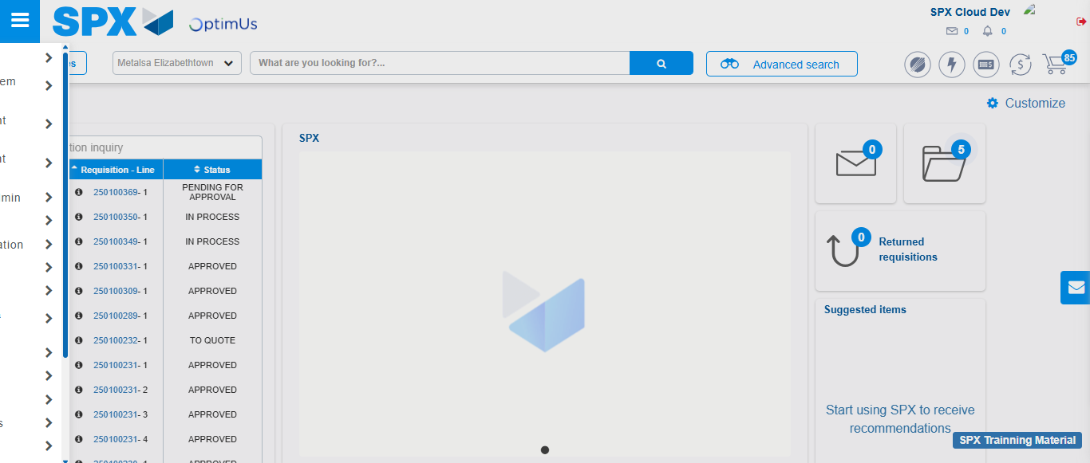Image file-name: QC_Testing-tc008_SPX_Dev5_Validacion_Boton_Remove_Administrador_Menu-nov. 20 2025, 02 43 21 p. m.

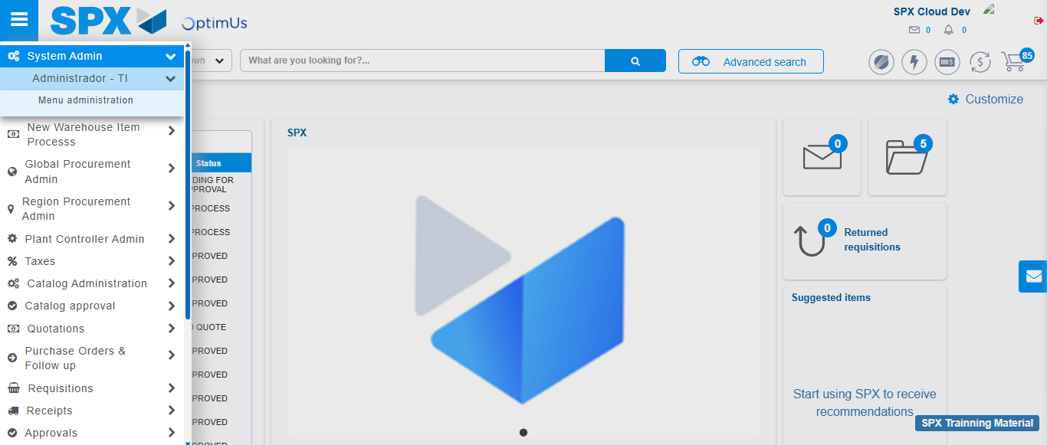Image file-name: QC_Testing-tc008_SPX_Dev5_Validacion_Boton_Remove_Administrador_Menu-nov. 20 2025, 02 43 22 p. m.

Image file-name: QC_Testing-tc008_SPX_Dev5_Validacion_Boton_Remove_Administrador_Menu-nov. 20 2025, 02 43 24 p. m.

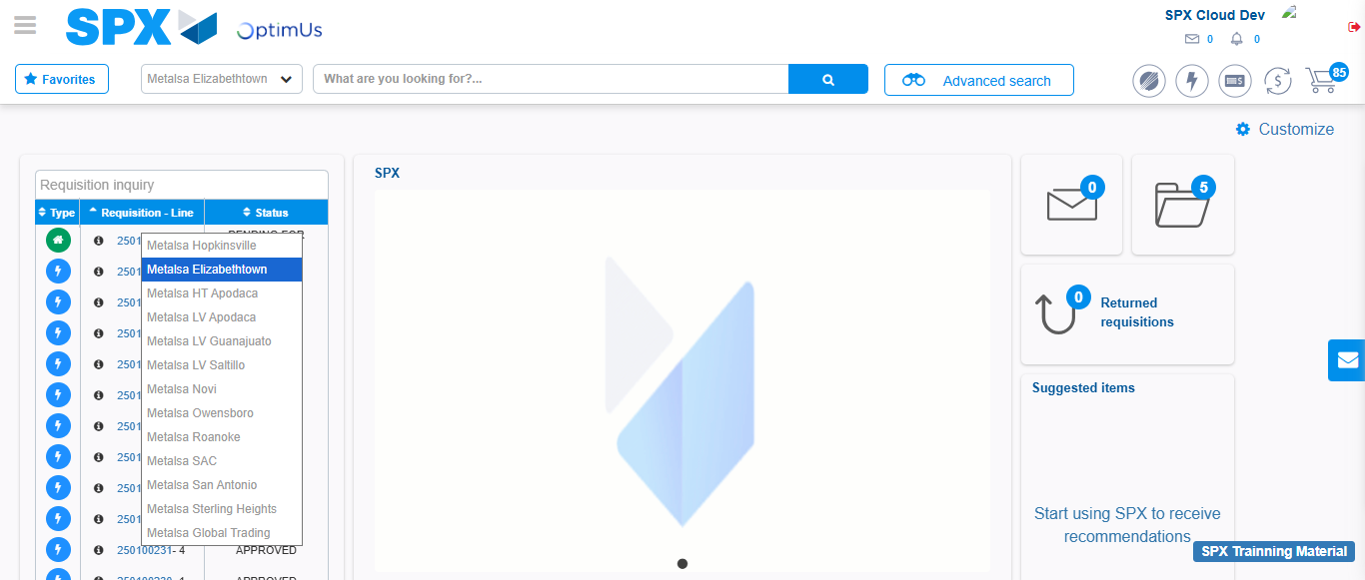Image file-name: QC_Testing-tc009_SPX_Dev5_Validacion_Campos_Busqueda_Articulos_Controlados-nov. 20 2025, 02 43 45 p. m.

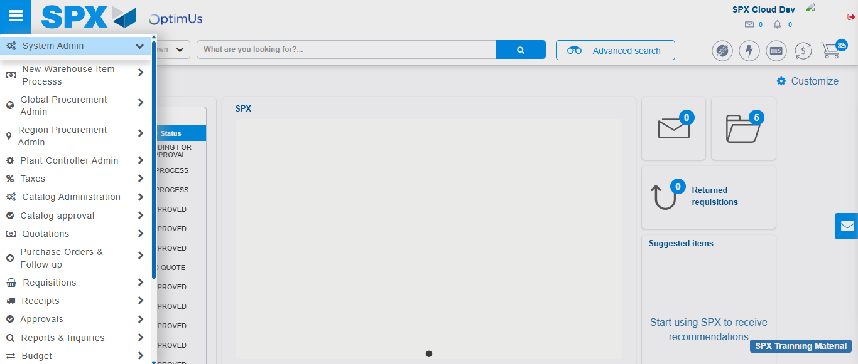Image file-name: QC_Testing-tc009_SPX_Dev5_Validacion_Campos_Busqueda_Articulos_Controlados-nov. 20 2025, 02 43 46 p. m.

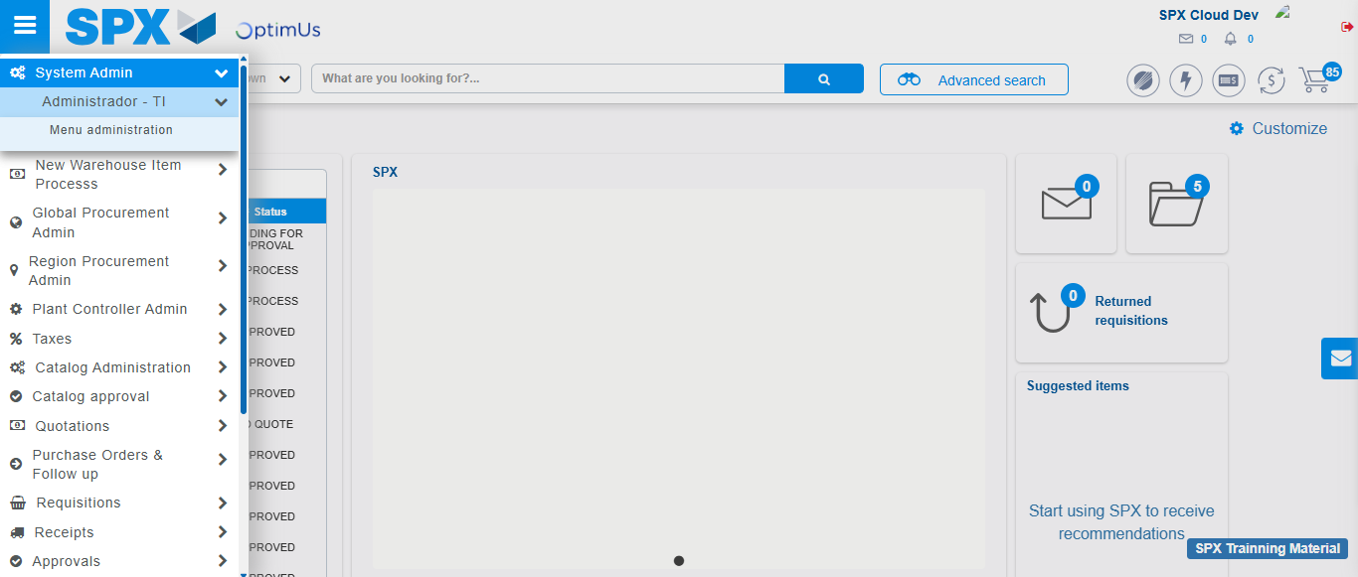Image file-name: QC_Testing-tc009_SPX_Dev5_Validacion_Campos_Busqueda_Articulos_Controlados-nov. 20 2025, 02 43 47 p. m.

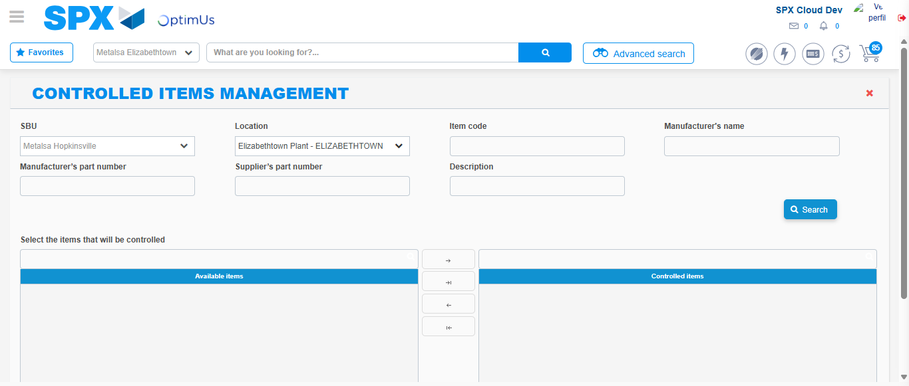Image file-name: QC_Testing-tc009_SPX_Dev5_Validacion_Campos_Busqueda_Articulos_Controlados-nov. 20 2025, 02 43 51 p. m.

Image file-name: QC_Testing-tc010_SPX_Dev5_Validacion_Agregar_Remover_Articulos_Controlados-nov. 20 2025, 02 44 42 p. m.

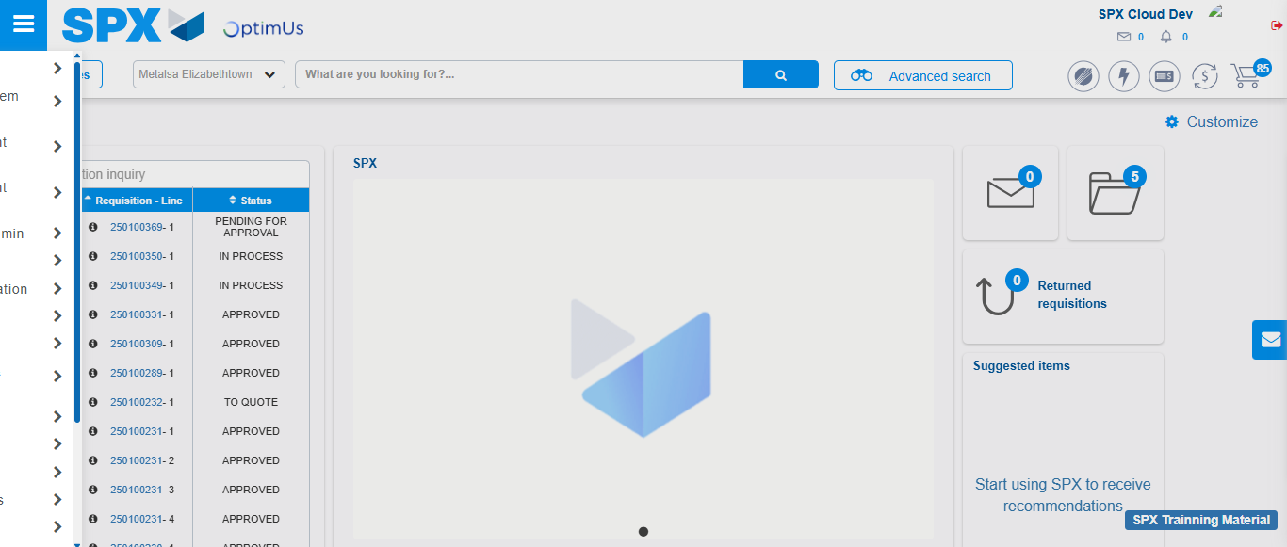Image file-name: QC_Testing-tc010_SPX_Dev5_Validacion_Agregar_Remover_Articulos_Controlados-nov. 20 2025, 02 44 43 p. m.

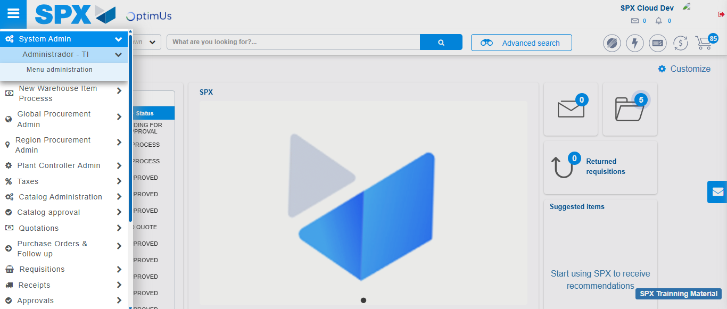Image file-name: QC_Testing-tc010_SPX_Dev5_Validacion_Agregar_Remover_Articulos_Controlados-nov. 20 2025, 02 44 44 p. m.

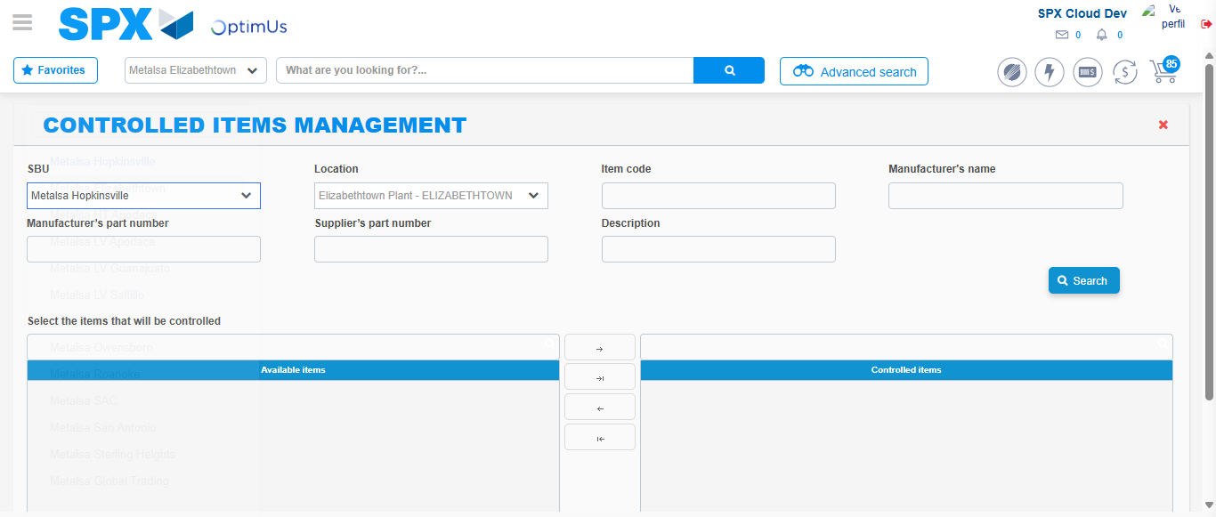Image file-name: QC_Testing-tc010_SPX_Dev5_Validacion_Agregar_Remover_Articulos_Controlados-nov. 20 2025, 02 44 48 p. m.

Step 3 - Validation buttons Add & Remove: Correct buttons validation
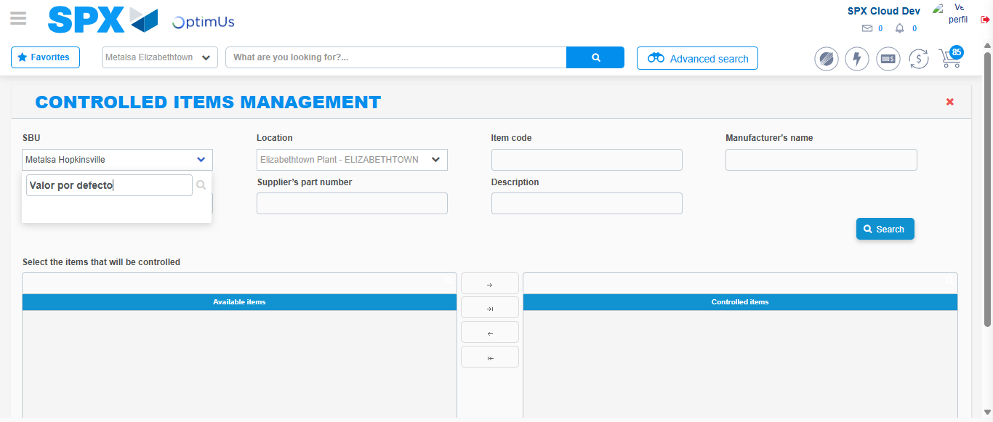Image file-name: QC_Testing-tc009_SPX_Dev5_Validacion_Campos_Busqueda_Articulos_Controlados-nov. 20 2025, 02 43 52 p. m.

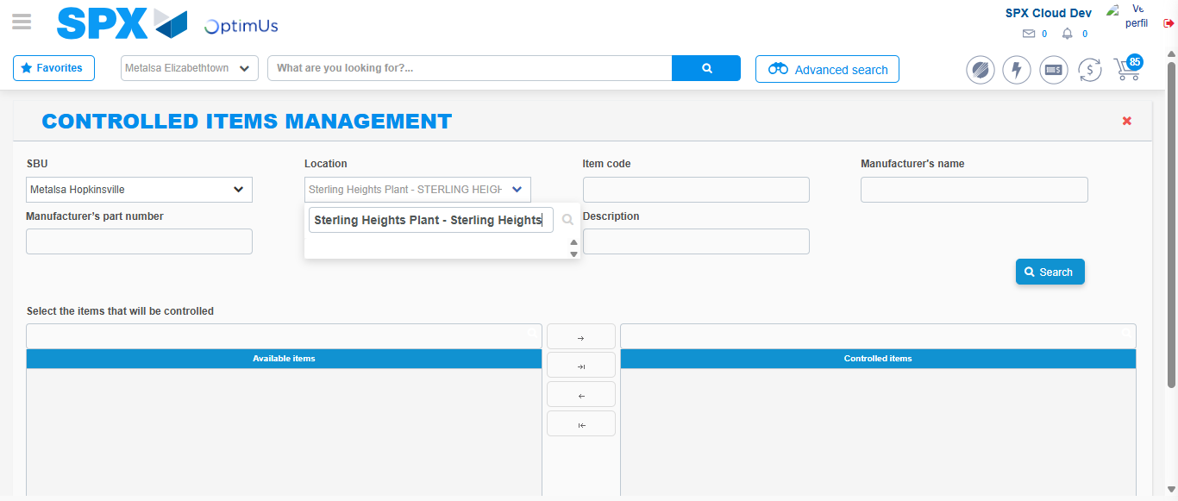Image file-name: QC_Testing-tc009_SPX_Dev5_Validacion_Campos_Busqueda_Articulos_Controlados-nov. 20 2025, 02 44 03 p. m.

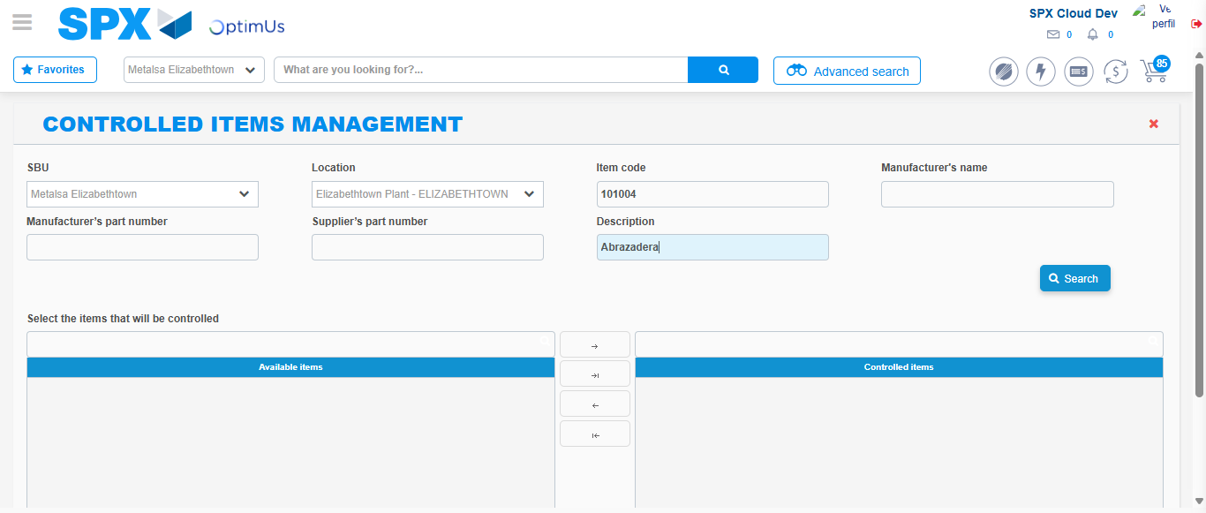Image file-name: QC_Testing-tc009_SPX_Dev5_Validacion_Campos_Busqueda_Articulos_Controlados-nov. 20 2025, 02 44 14 p. m.

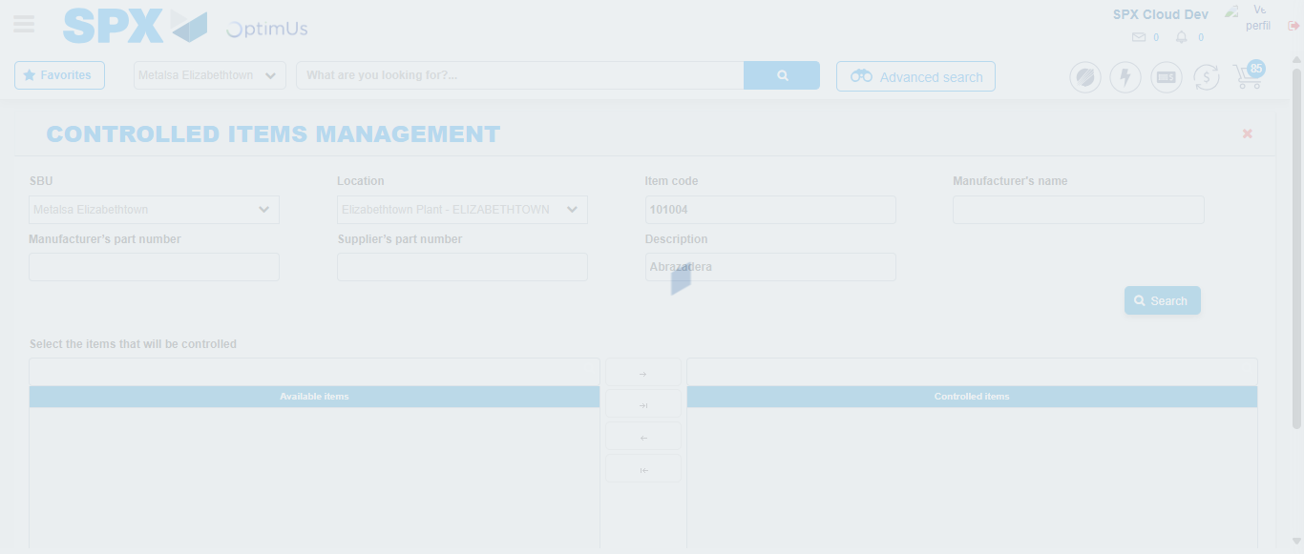Image file-name: QC_Testing-tc009_SPX_Dev5_Validacion_Campos_Busqueda_Articulos_Controlados-nov. 20 2025, 02 44 15 p. m.

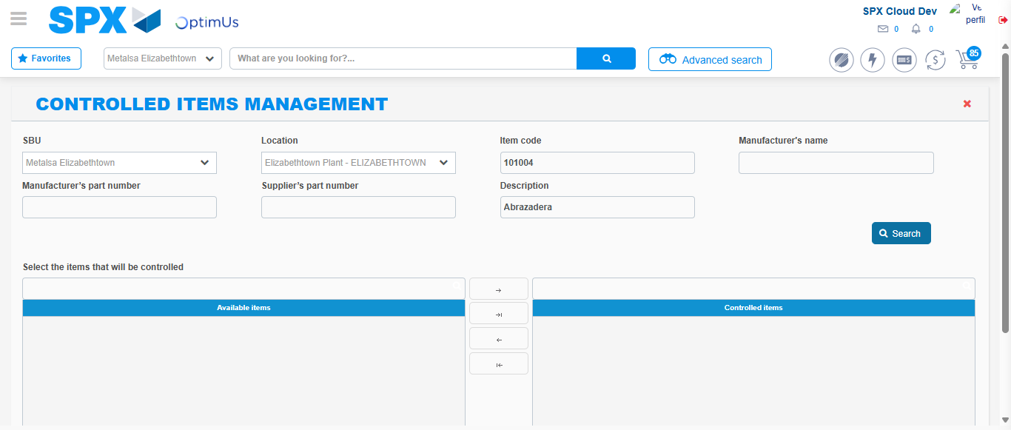Image file-name: QC_Testing-tc009_SPX_Dev5_Validacion_Campos_Busqueda_Articulos_Controlados-nov. 20 2025, 02 44 26 p. m.

Image file-name: QC_Testing-tc010_SPX_Dev5_Validacion_Agregar_Remover_Articulos_Controlados-nov. 20 2025, 02 44 48 p. m.

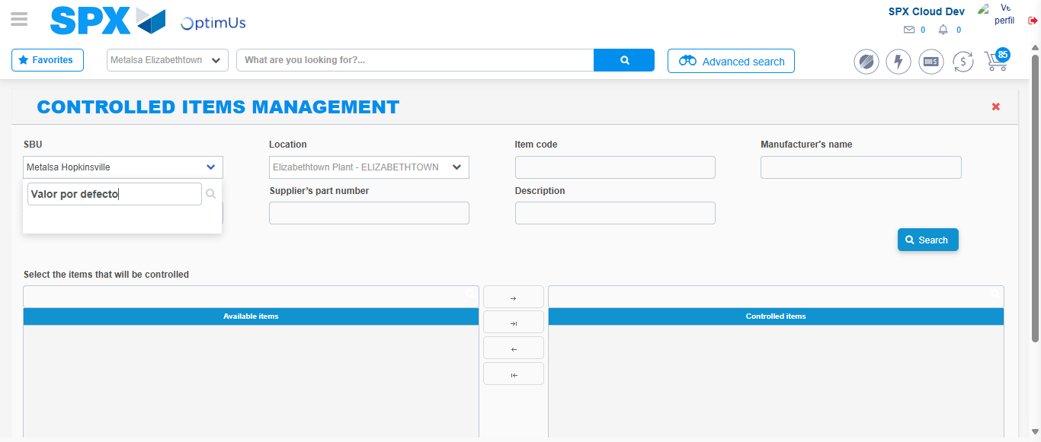Image file-name: QC_Testing-tc010_SPX_Dev5_Validacion_Agregar_Remover_Articulos_Controlados-nov. 20 2025, 02 44 49 p. m.

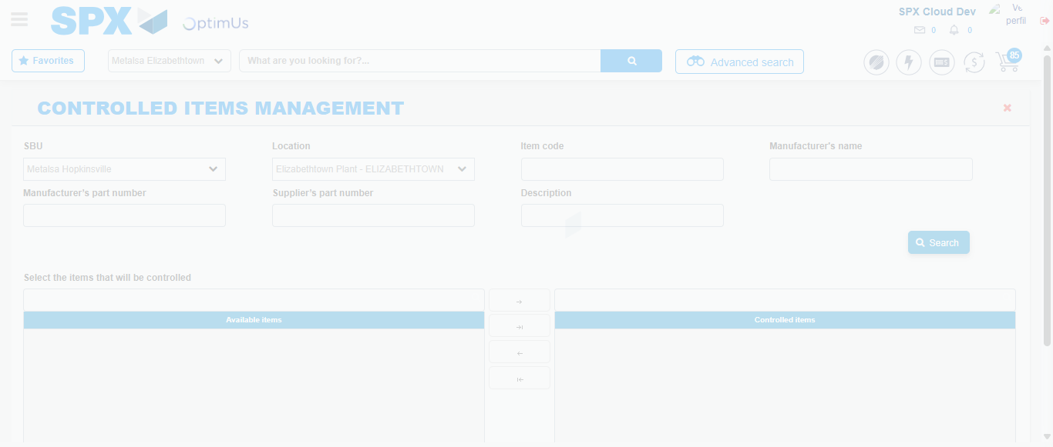Image file-name: QC_Testing-tc010_SPX_Dev5_Validacion_Agregar_Remover_Articulos_Controlados-nov. 20 2025, 02 44 59 p. m.

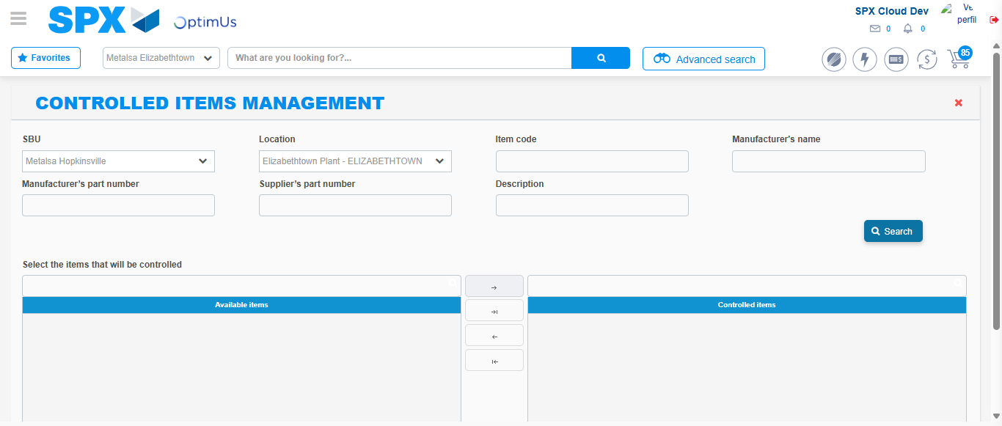Image file-name: QC_Testing-tc010_SPX_Dev5_Validacion_Agregar_Remover_Articulos_Controlados-nov. 20 2025, 02 45 10 p. m.

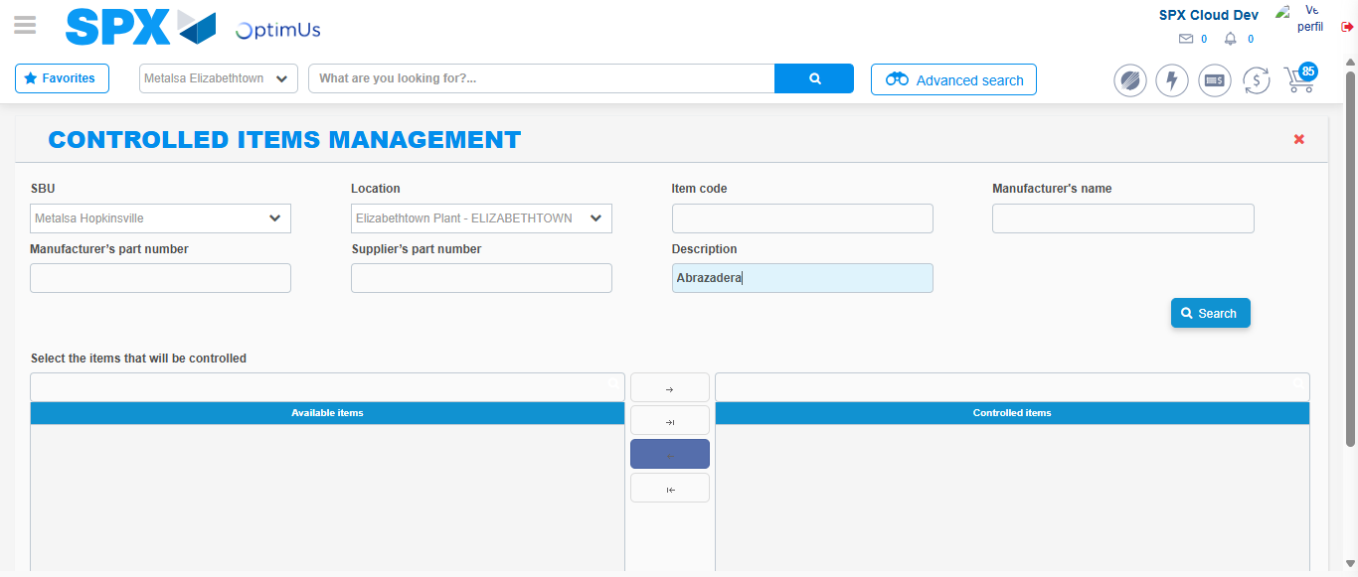Image file-name: QC_Testing-tc010_SPX_Dev5_Validacion_Agregar_Remover_Articulos_Controlados-nov. 20 2025, 02 45 23 p. m.

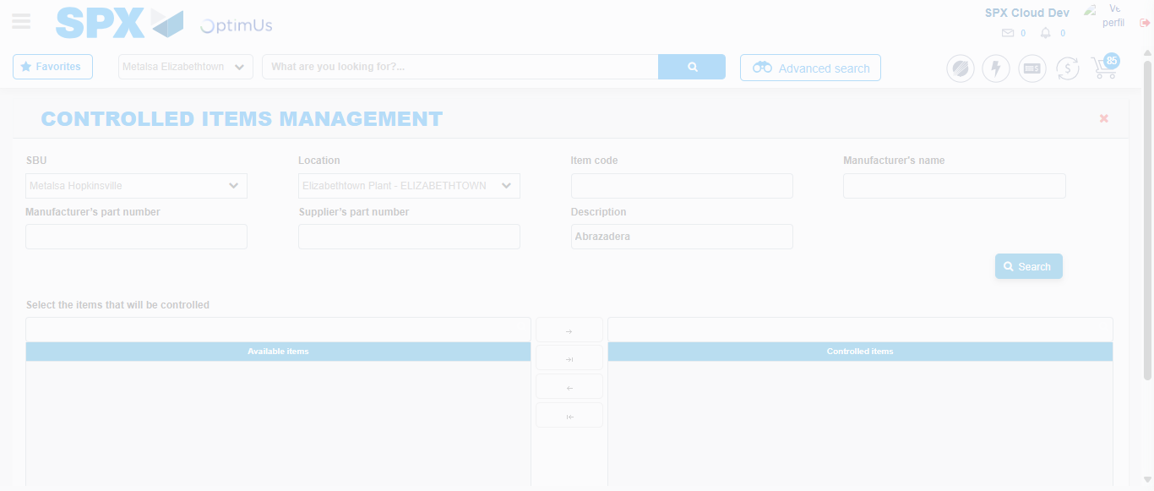Image file-name: QC_Testing-tc010_SPX_Dev5_Validacion_Agregar_Remover_Articulos_Controlados-nov. 20 2025, 02 45 24 p. m.

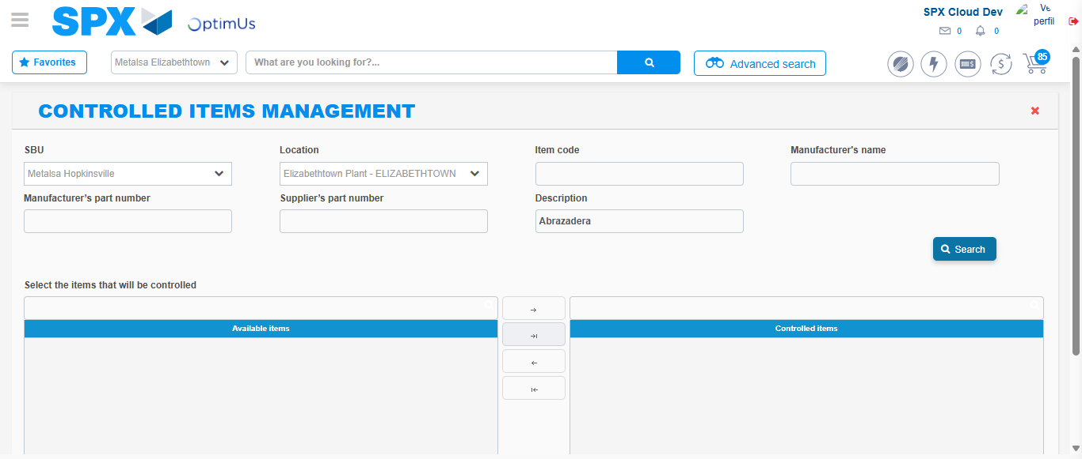Image file-name: QC_Testing-tc010_SPX_Dev5_Validacion_Agregar_Remover_Articulos_Controlados-nov. 20 2025, 02 45 27 p. m.

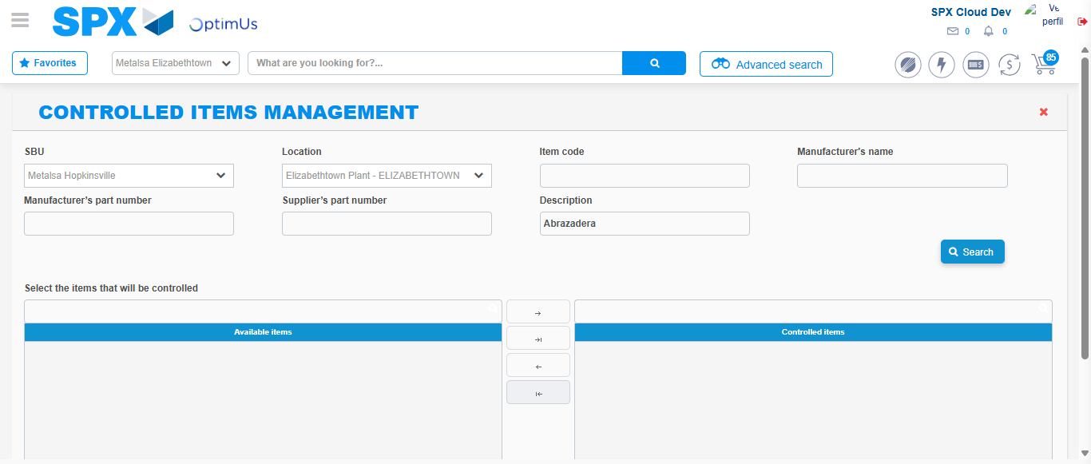Image file-name: QC_Testing-tc010_SPX_Dev5_Validacion_Agregar_Remover_Articulos_Controlados-nov. 20 2025, 02 45 30 p. m.

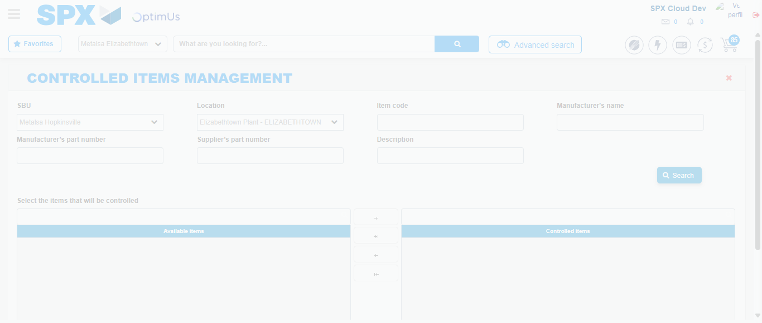Image file-name: QC_Testing-tc010_SPX_Dev5_Validacion_Agregar_Remover_Articulos_Controlados-nov. 20 2025, 02 45 34 p. m.

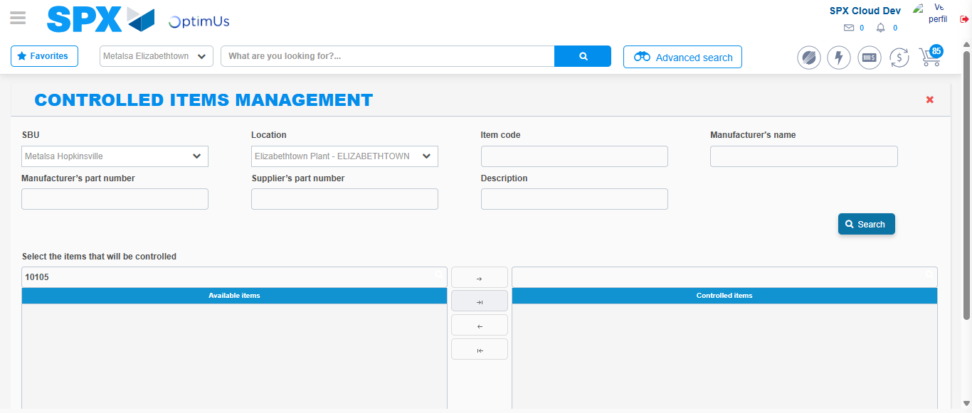Image file-name: QC_Testing-tc010_SPX_Dev5_Validacion_Agregar_Remover_Articulos_Controlados-nov. 20 2025, 02 45 37 p. m.

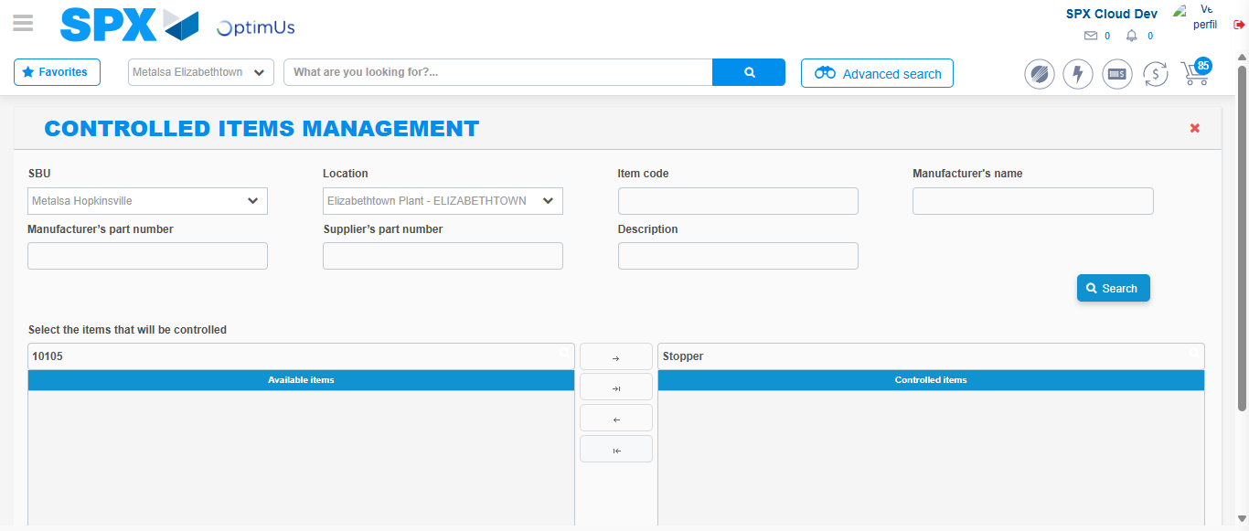Image file-name: QC_Testing-tc010_SPX_Dev5_Validacion_Agregar_Remover_Articulos_Controlados-nov. 20 2025, 02 45 41 p. m.

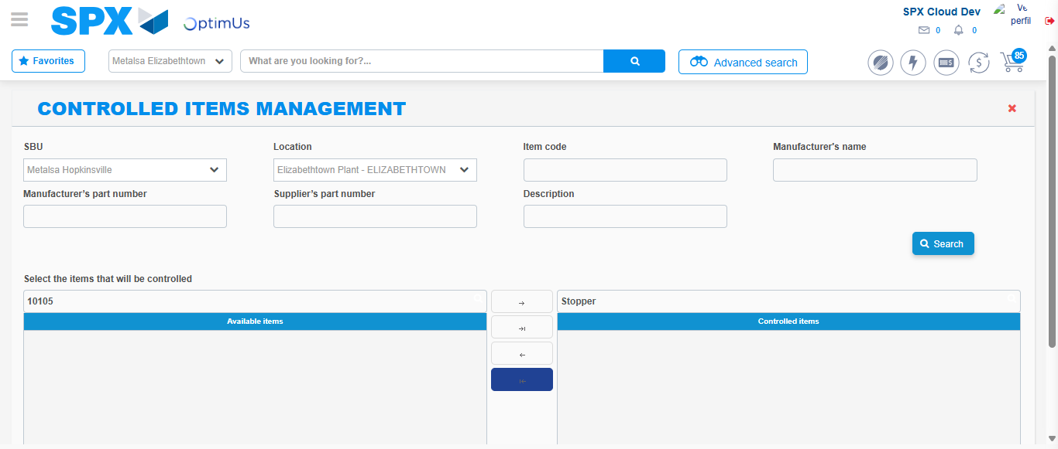Image file-name: QC_Testing-tc010_SPX_Dev5_Validacion_Agregar_Remover_Articulos_Controlados-nov. 20 2025, 02 45 44 p. m.

